UPC logo - vectored

COVID-19 Handbook Supplement

2020 – 2021

Updated 11/24/2020 LT

**PURPOSE:**

The purpose of the COVID-19 Handbook Supplement is to provide details on how UPC Discovery intends to meet the new health and safety standards surrounding COVID-19. This document will serve as written communication to all staff, parents, and visitors detailing how UPC Discovery will minimize risk of transmission of COVID-19. This document is a working document which is anticipated to be updated frequently in accordance with recommendations from our civil authorities, the CDC, DCFS, and the IDPH.

**DAILY HEALTH SCREENINGS:**

Upon arrival at the center, daily health checks will be conducted for all persons who plan to enter the building. All health checks will take place outside under the portico and before entering the building. All staff, children, and parents must wear a mask upon arrival at the center. Staff will use non-contact infrared thermometers and will not need to change gloves before each temperature check. Should staff come in physical contact during a temperature check, gloves will be changed. Should the thermometer come in contact during a temperature check, it will be cleaned with an alcohol wipe. Staff will keep logs as documentation that temperature checks were completed on all persons entering UPC Discovery.

Children- As children arrive at UPC Discovery daily, they will be required to wear face masks. All children will remain in their vehicles until the temperature check and screening procedures are complete. While in the vehicle, staff will check and record temperatures using a no contact infrared thermometer. Staff members will also ask parents a series of questions regarding symptoms and exposure of COVID-19. If a temperature is over 100.4 degrees Fahrenheit or the child is showing any symptoms of COVID-19, the child will not be permitted to enter the facility and the parent will be encouraged to see a health care provider to have their child evaluated. Once a staff member has taken a child’s temperature and conducted a health screening, the child will be permitted to exit the vehicle. A staff member will then escort the child to a designated waiting area outside the building until the arrival of all children in a designated class. Once inside the building, children will use hand sanitizer and proceed to their classrooms designated bathroom. Children should be rechecked for fever during the day if they begin to feel ill or experience any sign of respiratory illness.

Daily attendance/health screening logs will be recorded and kept in the Director’s office.

Parents, Legal Guardians, or other persons authorized for drop-off/pick-up- Upon arrival parents will drive under the portico in the back of the church for drop off. All parents should remain in their vehicle and wear a face mask. Parents are encouraged to be on the lookout for signs of illness in their children and keep them home if they are exhibiting signs of any illness. At this time, parents will not be permitted in the building for drop off or pick up. Should the need arise, any parents who enter the building will have their temperatures checked and recorded, as well as asked a series of questions in regards to symptoms and exposure to COVID-19. If a temperature is over 100.4 degrees Fahrenheit or the parent or legal guardian is showing any symptoms of COVID-19, the parent/legal guardian will not be permitted to enter the facility and will be encouraged to see a health care provider for evaluation. At times, aftercare children will be picked up from the playground. Parents may approach the playground area if wearing a mask. Please be aware that only current students and staff are allowed in the playground area beyond the metal fence. Daily attendance/health screening logs will be recorded and kept in the Director’s office.

Visitors- Visitors are not permitted into the classrooms unless necessary for the health, safety, and education of the children. Visitors should always be masked while inside the facility, unless they have medical conditions or disabilities that prevent use of a face covering. All visitors who enter the building are required to have temperature checks, as well as answer a series of questions in regards to symptoms and exposure to COVID-19. If a temperature is over 100.4 degrees Fahrenheit or the visitor is showing any symptoms of COVID-19, the visitor will not be permitted to enter the facility and will be encouraged to see a health care provider for evaluation. Daily attendance/health screening logs will be recorded and kept in the Director’s office.

Staff- Staff will take temperatures and conduct a personal health screening upon entering the building at the beginning of their reported work period. All staff will enter the doors under the portico and must use the provided infrared thermometers and hand sanitizer. Upon arrival to the classroom, staff must immediately wash their hands. If a temperature is over 100.4 degrees Fahrenheit or the staff member is showing any symptoms of COVID-19, the staff member will not be permitted to enter the facility and will be required to see a health care provider for evaluation. Staff should be rechecked for fever during their work period if they begin to feel ill or experience any sign of respiratory illness. Records for monitoring temperatures and health screenings will be maintained.

**SYMPTOMS OF COVID_19**

People with COVID-19 have had a wide range of symptoms reported – ranging from mild symptoms to severe illness. Symptoms may appear **2-14 days after exposure** **to the virus.** People with these symptoms may have COVID-19:

* Fever or chills
* Cough
* Shortness of breath or difficulty breathing
* Fatigue
* Muscle or body aches
* Headache
* New loss of taste or smell
* Sore throat
* Congestion or runny nose
* Nausea or vomiting
* Diarrhea
* Repeated shaking with chills

Common human coronaviruses usually cause mild to moderate upper-respiratory tract illnesses, like the common cold. These illnesses usually only last for a short amount of time. Human coronaviruses can sometimes cause lower-respiratory tract illnesses, such as pneumonia or bronchitis.

If your child is displaying any of the above symptoms, please note they will not be able to stay for the school day. Please refer to the process below in order to determine next steps in the isolation/quarantine process. This list does not include all possible symptoms. The CDC will continue to update this list as they continue to learn more about COVID-19.

**ISOLATION AND DISCHARGE OF SICK CHILDREN AND STAFF:**

Any child or staff member suspected of having COVID-19 or diagnosed with COVID-19 shall be excluded from the facility pursuant to existing licensing standards regarding communicable disease, 89Ill. Adm. Code 406, 407, and 408. The following procedures will be used when a suspected or confirmed COVID-19 case is present at UPC Discovery. These guidelines are taken directly from IDPH website. <https://www.dph.illinois.gov/covid19/community-guidance/guidance-pre-k-12-schools-and-day-care-programs-addressing-covid-19>

**Procedures for Students, Faculty, and Support Staff who Test Positive:**

* If a student tests positive- An immediate notification should be sent to the Director of UPC Discovery. This communication should come from the parent or legal guardian of the child in attendance at UPC Discovery. In an effort to keep information private, please only contact the Director of UPC Discovery if your student tests positive.
* If a staff member tests positive- An immediate notification should be sent to the Director of UPC Discovery. This communication should come directly from the staff member who is an employee of UPC Discovery. In an effort to keep information private, please only contact the Director of UPC Discovery if you test positive.
* The Director of UPC Discovery should send an immediate written notification to the DCFS licensing representative, as well as, the Local Health Department (LHD) The Director of UPC Discovery, DCFS, and the LHD shall determine the next steps. The Director of UPC Discovery should share with DCFS and the LHD all available information about the case’s movements and potential exposures within the facility. This includes:
  + Total number of classrooms impacted
  + Total number of students at the school/day care and total number of classrooms
  + Total number of staff at the school/day care
  + Total number of students and staff potentially exposed
  + The COVID-positive individual’s reported/observed onset date of symptoms
  + The COVID-positive individual’s last day at the school/day care
  + Any other important information asked for on the COVID-19 Data Collection Document provider from DCFS to the Director of UPC Discovery.
* The LHD will contact the COVID-positive staff person, or the parents/guardians of the COVID-positive child to complete the investigation and conduct contact tracing to identify close contacts to the case (persons within 6 feet, for at least 15 minutes cumulatively while the individual was infectious).
* If the COVID-positive child/staff person was at UPC Discovery during their infectious period, i.e., from 48 hours prior to symptom onset (for a symptomatic person) or, 48 hours before specimen collection (for an asymptomatic person) through the date of last attendance, areas used by the individual should be cleaned and disinfected thoroughly according to [CDC guidelines](https://www.cdc.gov/coronavirus/2019-ncov/community/disinfecting-building-facility.html?CDC_AA_refVal=https%3A%2F%2Fwww.cdc.gov%2Fcoronavirus%2F2019-ncov%2Fprepare%2Fdisinfecting-building-facility.html) and as described below.
* The Director of UPC Discovery will notify families, teachers, and support staff while maintaining confidentiality as required by the Americans with Disabilities Act (ADA) and the Family Educational Rights and Privacy Act. The notification should be sent as soon as possible and include information on symptom monitoring, what to do if symptoms develop, COVID-19 prevention strategies, and information on what UPC Discovery is doing in response to the positive case. In advance of a positive case,
* The COVID-positive individual should remain in home isolation as instructed by the LHD.
* Before isolation precautions are discontinued and clearance is granted for entry or return to UPC Discovery, CDC’s [Discontinuation of Isolation](https://www.cdc.gov/coronavirus/2019-ncov/hcp/disposition-in-home-patients.html) requirements should be met. This requires communication of clearance from the Director of UPC Discovery, as well as written documentation from the LHD. Should the Director of UPC Discovery feel isolation or quarantine time was not sufficient, the child or staff member may be denied entry back into the classroom.

**Procedures for Students, Faculty and Support Staff who are Close Contacts to a Confirmed COVID-19 Case:**

* Should someone in the household of a current student or staff member of UPC Discovery, parents of the student or staff member should report the positive case to the Director of UPC Discovery immediately.
* The Director of UPC Discovery shall provide to the LHD attendance records, classroom schedules, seating charts, transportation schedules, and staff assignments to identify close school contacts (within 6 feet for 15 minutes) to the COVID-positive child/staff person upon request.
* Close household and social contacts to a COVID-19 case will be identified by the LHD through contact tracing interviews with the COVID-positive staff person, or the parents/guardians of the COVID-positive child.
* UPC Discovery shall determine if other staff members not normally assigned to classrooms were exposed by reviewing records and interviewing staff.
* Close contacts to a case of COVID-19 should be [quarantined](https://www.cdc.gov/coronavirus/2019-ncov/if-you-are-sick/quarantine.html)at home for 14 days **after the last contact to a positive COVID-19 person**, as long as they remain asymptomatic. Siblings, parents/guardians, and other household members of the case who are deemed to be close contacts will also be quarantined. After completing 14 calendar days in quarantine, asymptomatic contacts may return to school/day care.
* If the contact becomes symptomatic during quarantine, they will be managed as a probable case (if not tested) or a confirmed case (if they test positive).
* Probable and confirmed cases should complete 10 days of isolation from the date of first symptom onset, demonstrate improvement of symptoms and be fever-free for 24 hours without use of fever-reducing medications before they are allowed to return to school/day care.
* Should a student or staff member become a close contact to a positive COVID-19 case, the Director of UPC Discovery , as well as the parent/legal guardian or staff member shall work together to determine a return date to the classroom.

**Procedures for Students, Teachers, and Support Staff who Become Sick at School/Day Care:**

* If a student or staff person at a school or day care becomes sick with COVID-like symptom, the school or day care should immediately notify the LHD.
* The student or staff person who becomes sick while at school/day care or arrives sick with a [COVID-like symptom(s)](https://www.cdc.gov/coronavirus/2019-ncov/symptoms-testing/symptoms.html) should be immediately masked, if not already so, and sent to the designated separation room (a room that can be used to isolate a sick child for evaluation of the sick individual).
* If the nurse is screening a symptomatic student, it will be safest for them to be wearing fit tested N95 mask, eye protection with face shield or goggles, gown and gloves. With N95 masks, the user should be trained on the type of PPE required and how to don (put on) and doff (remove) it correctly and safely. Respirators such as N95s must be used as part of a written respiratory protection program. OSHA requires that N95 masks be fit tested prior to use. This is an important step to ensure a tight fit for the mask to be effective in providing protection. Schools should contact their LHD to determine where fit testing can be obtained in their area.
* Based on clinical assessments and when possible (e.g., schools with school-based health clinics), the sick individual should be tested for COVID-19 and other respiratory viruses, where indicated. Depending on the severity of illness:

Sick students and staff should be:

* + - * safely transported home by parent or guardian as soon as possible, or
      * safely transported by parent or guardian to a healthcare facility for clinical evaluation and testing, if necessary.
* Schools/day cares are encouraged to work with their LHD to arrange for medical evaluation and testing options to ensure testing arrangements can be made quickly when indicated.
* Sick individuals should remain in home isolation until testing is completed. If COVID-negative, the child or staff person should remain out of school/day care until they have been afebrile (fever-free) for 24 hours without fever-reducing medication, and symptoms improved.
* If they test COVID-positive, refer to the section, “Procedures for Students, Faculty and Support Staff who Test Positive.”
* If testing is not performed due to the clinical judgment of the healthcare provider, a medical note is needed to return to school/day care documenting that there is no clinical suspicion for COVID-19 infection and indicate an alternative diagnosis with exclusion consistent with this diagnosis, e.g., 24 hours afebrile.
* If testing is not performed for other reasons, the child should remain out of school/day care for 10 calendar days after symptom onset and 24 hours afebrile (fever-free) without fever-reducing medication and symptoms improved.
* All areas used by the sick individual should be cleaned and disinfected thoroughly according to [CDC guidelines](https://www.cdc.gov/coronavirus/2019-ncov/community/disinfecting-building-facility.html?CDC_AA_refVal=https%3A%2F%2Fwww.cdc.gov%2Fcoronavirus%2F2019-ncov%2Fprepare%2Fdisinfecting-building-facility.html) and as described below.

**Procedures for Contact Tracing and Quarantining Persons Exposed to a Confirmed COVID-19 Case:**

* Parents/guardians of a COVID-positive child, or a COVID-positive staff person will be interviewed by personnel from the LHD. The purpose for the interview is to identify everyone with whom the COVID-positive individual had close contact (within 6 feet for a cumulative 15 minutes or more while the individual was infectious).
* The infectious period begins 2 days before the onset of symptoms (for a symptomatic person) or 2 days before the positive sample was obtained (for an asymptomatic person) and ends when the COVID-positive individual was placed in isolation. Factors to consider when defining close contact include proximity, the duration of exposure (e.g., longer exposure time likely increases exposure risk), and whether the exposure was to a person with symptoms (e.g., coughing likely increases exposure risk). Brief interactions are less likely to result in transmission; however, symptoms and the type of interaction (e.g., did the infected person cough directly into the face of the exposed individual) remain important.
* Parents/guardians and staff must cooperate with the LHD for purposes of conducting contact tracing or any outbreak pursuant to the Control of Communicable Disease Code, 77 Illinois Administrative Code 690.
* School/day care personnel will inform the LHDs about possible exposures within the school/day care, including transportation, classroom, common areas and extracurricular activities. Schools/day cares should designate a person for this role and have them available after hours.
* All close contacts to a confirmed case of COVID-19 will be placed in [quarantine](https://www.cdc.gov/coronavirus/2019-ncov/if-you-are-sick/quarantine.html)for 14 days  **after the last contact to a positive COVID-19 person** and monitored daily by the LHD for the onset of any signs and symptoms of COVID-19 . Testing of close contacts is also recommended and where possible, should be facilitated by the school/day care/LHD. CDC does not recommend universal testing of all students and staff. See [CDC’s Interim Considerations for testing in schools.](https://www.cdc.gov/coronavirus/2019-ncov/community/schools-childcare/k-12-testing.html)

**Procedures for Temporary Closure and Environmental Cleaning and Disinfection When a Confirmed or Possible Case of COVID-19 is Identified in a School/Day Care:**

* If a person diagnosed with COVID-19 is determined to have been within the school/day care during the 48 hours prior to symptom onset (for a symptomatic person) or 48 hours before specimen collection (for an asymptomatic person), the school/day care may be closed temporarily for cleaning and disinfection. School/day care closure will be determined by the LHD investigation as described below.
* An initial, temporary closure allows time for the LHD to gain a better understanding of the COVID-19 situation impacting the school/day care. This allows the LHD to help the school/day care determine appropriate next steps, including whether an extended dismissal duration is needed to stop or slow further spread of COVID-19.
* Areas used by the individual with COVID-19, e.g., classroom, restrooms, separation room in the School Nurse’s office, will be closed off for as long as practical before beginning cleaning and disinfection to minimize potential for exposure to respiratory droplets. If possible, wait up to 24 hours before beginning cleaning and disinfection.
* Cleaning staff should clean and disinfect all areas (e.g., offices, bathrooms, and common areas) used by the individual with COVID-19, focusing especially on frequently touched surfaces.
* Schools/day care facilities should clean, sanitize and disinfect toys and bedding per [CDC’s guidance.](https://www.cdc.gov/coronavirus/2019-ncov/community/schools-childcare/guidance-for-childcare.html)
* Windows should be opened to increase air circulation in the area used by the individual with COVID-19.
* If surfaces are dirty, they should be cleaned using a detergent or soap and water prior to disinfection.
* For disinfection, most common EPA-registered household disinfectants should be effective.

**Procedures for Outbreak Response and Consideration for Closure:**

* An outbreak is defined as two cases that are linked epidemiologically with respect to person, place, and time. In other words, the two cases have shared close contacts and location and have onsets within 14 calendar days of each other. Conversely, two cases that occurred in different time frames (at least calendar 15 days apart), separate locations, and having no common source of exposure would not constitute an outbreak.
* Once an outbreak is identified, the LHD will further investigate to determine the extent of exposures at the school/day care and what control measures are needed to mitigate the outbreak. Alternative social distancing strategies, less drastic than closure, might include:
  + Quarantining the affected classroom, especially for infant and toddler classrooms where masking is not achievable and social distancing is challenging.
  + Suspending in-person learning for affected classes.
  + Closing playgrounds.
  + Canceling non-essential activities and meetings.
  + Keeping students in stable class groups or classrooms and moving teachers between classes, if necessary.
  + Increasing spacing between students in classes.
  + Shortening the in-person school week.
  + Staggering school/day care start and lunch/break times across year groups or classes.

**Discontinuation of Isolation**

Accumulating evidence supports ending isolation and precautions for persons with COVID-19 using a symptom-based strategy. Specifically, researchers have reported that people with mild to moderate COVID-19 remain infectious no longer than 10 days after their symptoms began, and those with more severe illness or those who are severely immunocompromised remain infectious no longer than 20 days after their symptoms began. Therefore, CDC has updated the recommendations for discontinuing home isolation as follows:

**Persons with COVID-19 who have symptoms**and were directed to care for themselves at home may discontinue isolation under the following conditions:

* At least 10 days* have passed since symptom onset **and**
* At least 24 hours have passed since resolution of fever without the use of fever-reducing medications **and**
* Other symptoms have improved.

*A limited number of persons with severe illness may produce replication-competent virus beyond 10 days, which may warrant extending duration of isolation for up to 20 days after symptom onset. Consider consultation with infection control experts. See [Discontinuation of Transmission-Based Precautions and Disposition of Patients with COVID-19 in Healthcare Settings (Interim Guidance).](https://www.cdc.gov/coronavirus/2019-ncov/hcp/disposition-hospitalized-patients.html)

**Persons infected with SARS-CoV-2 who never develop COVID-19 symptoms**may discontinue isolation and other precautions 10 days after the date of their first positive RT-PCR test for SARS-CoV-2 RNA.

If there is substantial transmission in the local community, local health officials may suggest remote instruction as part of a community mitigation strategy. This longer-term, and likely broader-reaching, remote instruction is intended to slow transmission rates of COVID-19 in the community.

**Procedures for reporting a positive COVID-19 person (student, household member, or staff member) to UPC Discovery**

* Once testing is complete and a positive result is given, please contact the Director of UPC Discovery immediately. Email is [lora.taylor@upcdiscovery.org](mailto:lora.taylor@upcdiscovery.org) or phone is 309-693-7296.
* The Director of UPC Discovery will discuss the decision tree on the following page in order to determine next steps for returning to the classroom. Remember the 14 day quarantine period begins after the last contact with a COVID-19 person OR when the COVID-19 person 10 day period is complete.
* Contact your Local Health Department to receive a Release from Quarantine letter.
* Discuss with the Director of UPC Discovery a return to school date. **Please note that even with a letter from the LHD, the Director of UPC Discovery reserves the right to deny entry into the classroom if he/she feels the quarantine time was not adequate according to the CDC Guidelines or that a return would impact the health of others at UPC Discovery.**

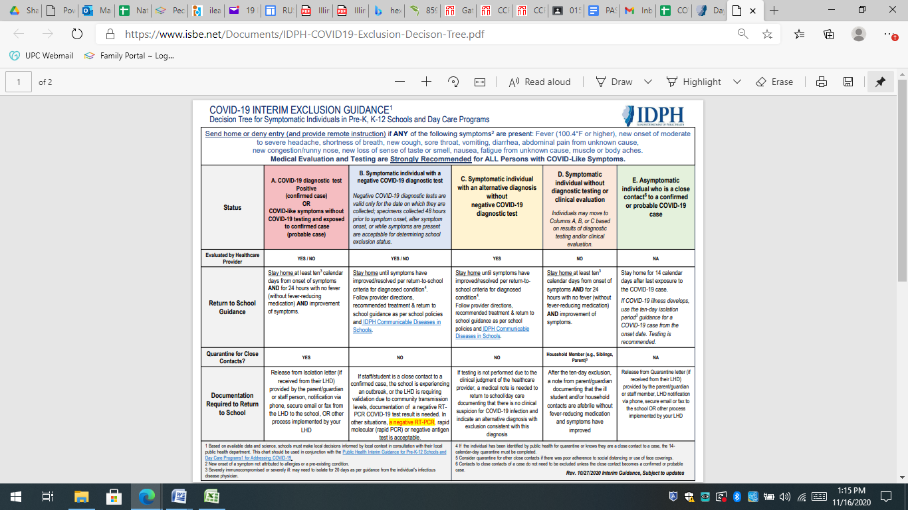

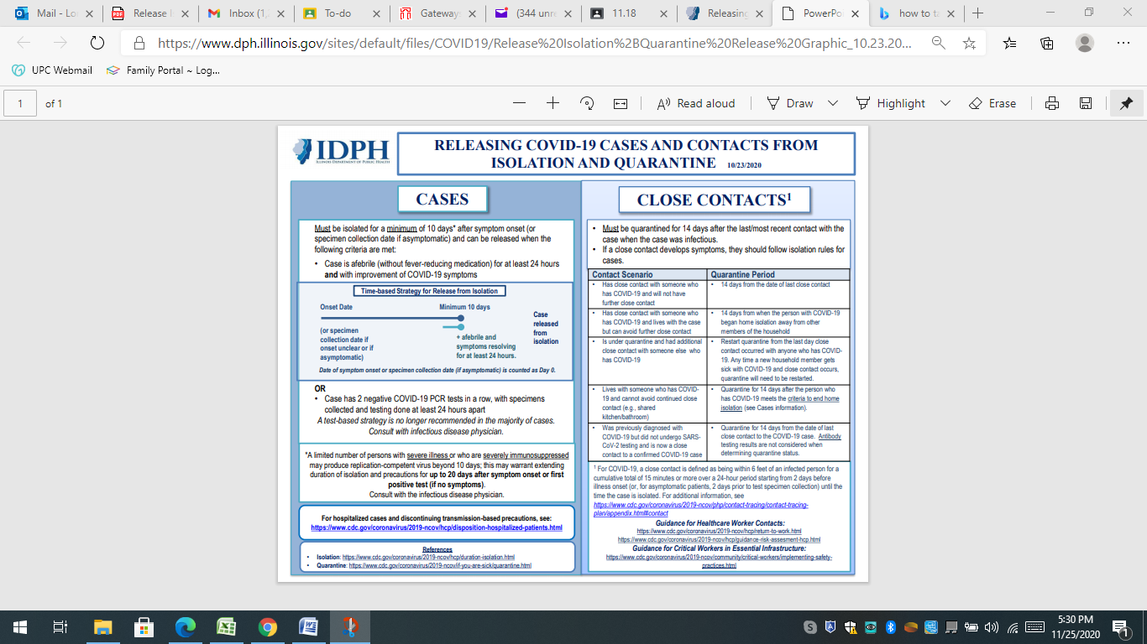

**HEALTH AND HYGIENCE PRACTICES:**

Every effort will be made daily to meet and maintain health and safety practices within all classrooms. Additional measures will be put into place to ensure the health and safety of the children and staff of UPC Discovery during the COVID_19 pandemic.

Hand washing/Hand Sanitizing- Upon arrival at UPC Discovery, all children and staff will practice appropriate hand washing procedures. Hand sanitizer will be utilized immediately at drop off each day. All staff and children will frequently engage in hand washing throughout the day including; before and after meals, using the bathroom, upon entering the building after being outdoors, and at other DCFS recommended times. An alcohol based sanitizer, as well as antibacterial hand soap, will also be available in each classroom. While outdoors, children and staff will have access to hand sanitizer, as well as antibacterial wipes.

Adequate cot spacing: During rest time, cots will be placed at least 6 feet from each other and cots will be utilized head to toe as needed.

Shared materials: Use of shared water play will be restricted during this time. Sprinklers outside will be permitted as long as social distancing procedures are in place. While outdoors, each classroom will have a separate set of play materials. These materials will be sanitized daily. Within the classroom, every effort will be made to clean and sanitize toys at the end of the day. Any toy that has been mouthed will immediately be removed for sanitizing.

Signage: Throughout the center, there will be signs placed to remind children and staff how to prevent the spread of germs. Hand washing signs will be maintained in each bathroom and by classroom hand washing sinks.

Cleaning and Sanitizing: All soft, plush toys will be removed from the classrooms as they can harbor germs and cannot be readily cleaned. Increased cleaning and sanitizing practices will occur on all high touch surfaces will occur often and as needed. These surfaces include but are not limited to: doorknobs, toys, light switches, phones, keyboards, and handles. At the end of the day, all classroom spaces utilized, including equipment and toys, will be thoroughly cleaned and disinfected.

Staggered arrival and dismissal times: Each classroom, including before care, will have staggered arrival and dismissal times. These times are spaced approximately 15 minutes apart and will help ensure children from each classroom maintain their distance. Please adhere to your drop off/pick up time and notify the classroom teacher or director if your assigned time cannot be maintained.

Group sizes and ratios: Children will remain with the same group of children and staff throughout the day. Groups will not be combined for any reason, including for outdoor play. In order to provide the level of supervision required to adhere to health and safety requirements, child-to-staff ratios will be minimized.

**PERSONAL PROTECTIVE EQUIPMENT**

In order to reduce transmission of COVID-19, UPC Discovery has developed a PPE plan for children and staff. The health and safety of our children and staff are imperative during this time. Every effort will be made to maintain PPE standards as outlined by DCFS, IDPH, and the CDC.

Types

1. Gloves- gloves shall be worn while serving food(food handler gloves), changing diapers, handling wounds, cleaning bodily fluids, and when using alcohol-based disinfectants. All COVID-19 screeners shall also wear gloves.
2. Face masks- Face masks are to be worn by staff and children while inside the building. Masks shall also be worn during COVID-19 screening at arrival and departure. Masks are not required during mealtimes, nap time, or during outdoor play, but staff members should ensure physical distancing is being practiced during these activities. All children wearing masks should be supervised at all times.
3. Face shields- face shields may be used by staff if preferred. Staff may remove shields during mealtimes in the classroom and during outdoor play.
4. Smocks- Staff who work between two classrooms in one day are required to wear a smock before entering each classroom. Smocks will be available should a staff member choose to wear one on a daily basis. Smocks shall be removed upon exiting the classroom and placed in the laundry basket in the Director’s office.

PPE Training: All staff will be required to attend PPE training. During this training, staff will learn more about the types of PPE, when to use PPE, and why to use PPE. The training will include an opportunity for staff to handle PPE and demonstrate they have an understanding of PPE and how to use it properly. If a staff member who has been trained demonstrates a lack of knowledge or behavior which leads the Director to believe the staff member does not have a proper understanding of PPE, that staff member will be retrained. If there are changes in workplace policies and procedures that affect PPE, then all staff will be retrained on any changes.

Staff will be trained on the proper way to disinfect the classroom. The training will include identifying often touched surfaces in the classroom, hallways, and bathrooms. Staff will understand what solutions to use when wiping surfaces and precautions to protect themselves when using disinfecting solutions.

**TRAVEL DURING COVID-19**

Travel increases your chance of getting and spreading COVID-19. **Staying home is the best way to protect yourself and others from COVID-19.**

You can get COVID-19 during your travels. You may feel well and not have any symptoms, but you can still spread COVID-19 to others. You and your travel companions (including [children](https://www.cdc.gov/coronavirus/2019-ncov/daily-life-coping/children/protect-children.html)) may spread COVID-19 to other people including your family, friends, and community for 14 days after you were exposed to the virus.

**Don’t travel if**[you are sick](https://www.cdc.gov/coronavirus/2019-ncov/if-you-are-sick/isolation.html) or [if you have been around someone with COVID-19 in the past 14 days](https://www.cdc.gov/coronavirus/2019-ncov/if-you-are-sick/quarantine.html). Don’t travel with someone who is sick.

State, local, and territorial governments may have travel restrictions in place, including testing requirements, stay-at-home orders, and quarantine requirements upon arrival. Follow state, local, and territorial travel restrictions. For up-to-date information and travel guidance, check the [state, territorial,](https://www.cdc.gov/publichealthgateway/healthdirectories/healthdepartments.html) [tribal](https://www.cdc.gov/tribal/index.html) and local health department where you are, along your route, and where you are going. Prepare to be flexible during your trip as restrictions and policies may change during your travel. This information can be found here: <https://www.cdc.gov/coronavirus/2019-ncov/travelers/>

**If you travel (especially to a “hot spot”), please notify the director of UPC Discovery in order to ensure all policies and procedures are put into place in regards to COVID-19 exposure.**

The following websites contain pertinent information about COVID-19. Please refer to these for specifics about the COVID-19 pandemic.

[www.cdc.gov](http://www.cdc.gov)

<http://dph.illinois.gov/>

<https://www2.illinois.gov/dcfs/Pages/default.aspx>

**All of the above recommendations, guidelines, and procedures are subject to change upon information gathered from DCFS, IDPH, and the CDC. UPC Discovery will notify parents and staff of any changes made.**

**Updated 11/24/2020 LT**