

Early Childhood Handbook

2019– 2020

Table of Contents

Mission 4
Program Goals 4
Children with Special Needs 5
Toileting Policy 5
Behavior Expectations 5
Parent Involvement 6
Enrollment and Discharge Policy 7
Calendar 7
Snack. 7
Lunch 8
Health Examinations 8
Birth Certificate Requirement 8
Drop Off / Pick Up 9
After Care Program Tardy Policy 9
Health & Safety/Absence & Illness 9
Medication at School 11
Food Allergies 12
Pesticide Policy 12
Guidance Procedures 12
Hours Of Operation 13
Classroom Video Camera 13
Fees 13
1/2 Day Preschool Daily Classroom Schedule 14
Full Day Preschool Daily Classroom Schedule 15
Toddler Daily Classroom Schedule 15
Curriculum 16
The Program 16
Play Based Learning 16
Faith Based Learning 17
Nature-Based Learning 17
Arts Based Learning 18
Literacy Position Statement. 18
Work Sampling 19
Toddler Assessment 19
Quick Reference Sheet 20

United Presbyterian Church



Welcome to UPC Discovery Early Learning Center, a ministry of United Presbyterian Church. Our mission at United Presbyterian Church is to share the love and Grace of God through worship, education, mission, and fellowship. UPC Discovery is just one way we seek to share God’s love and grace. You are always welcome at United Presbyterian Church and I hope you experience the love and nurture of God when you and your children are here. Welcome and God Bless.

The UPC Discovery Preschool Committee

UPC Discovery

Mission
United Presbyterian Church embraces all God’s children and celebrates the wonder of early childhood. UPC Discovery Early Learning Center is committed to educating children of all backgrounds and to valuing each child as a member of God’s diverse family. We partner with parents, the child’s first teacher, to engage the whole family on the learning journey and draw them closer to God and God’s church. We strive to provide children with opportunities to develop socially, emotionally, intellectually, and morally in an environment that fosters faith, cooperation, creativity, independence, and a love of learning. Caring and highly trained teachers implement a developmentally appropriate curriculum that encourages children to explore, take risks, create, and discover.

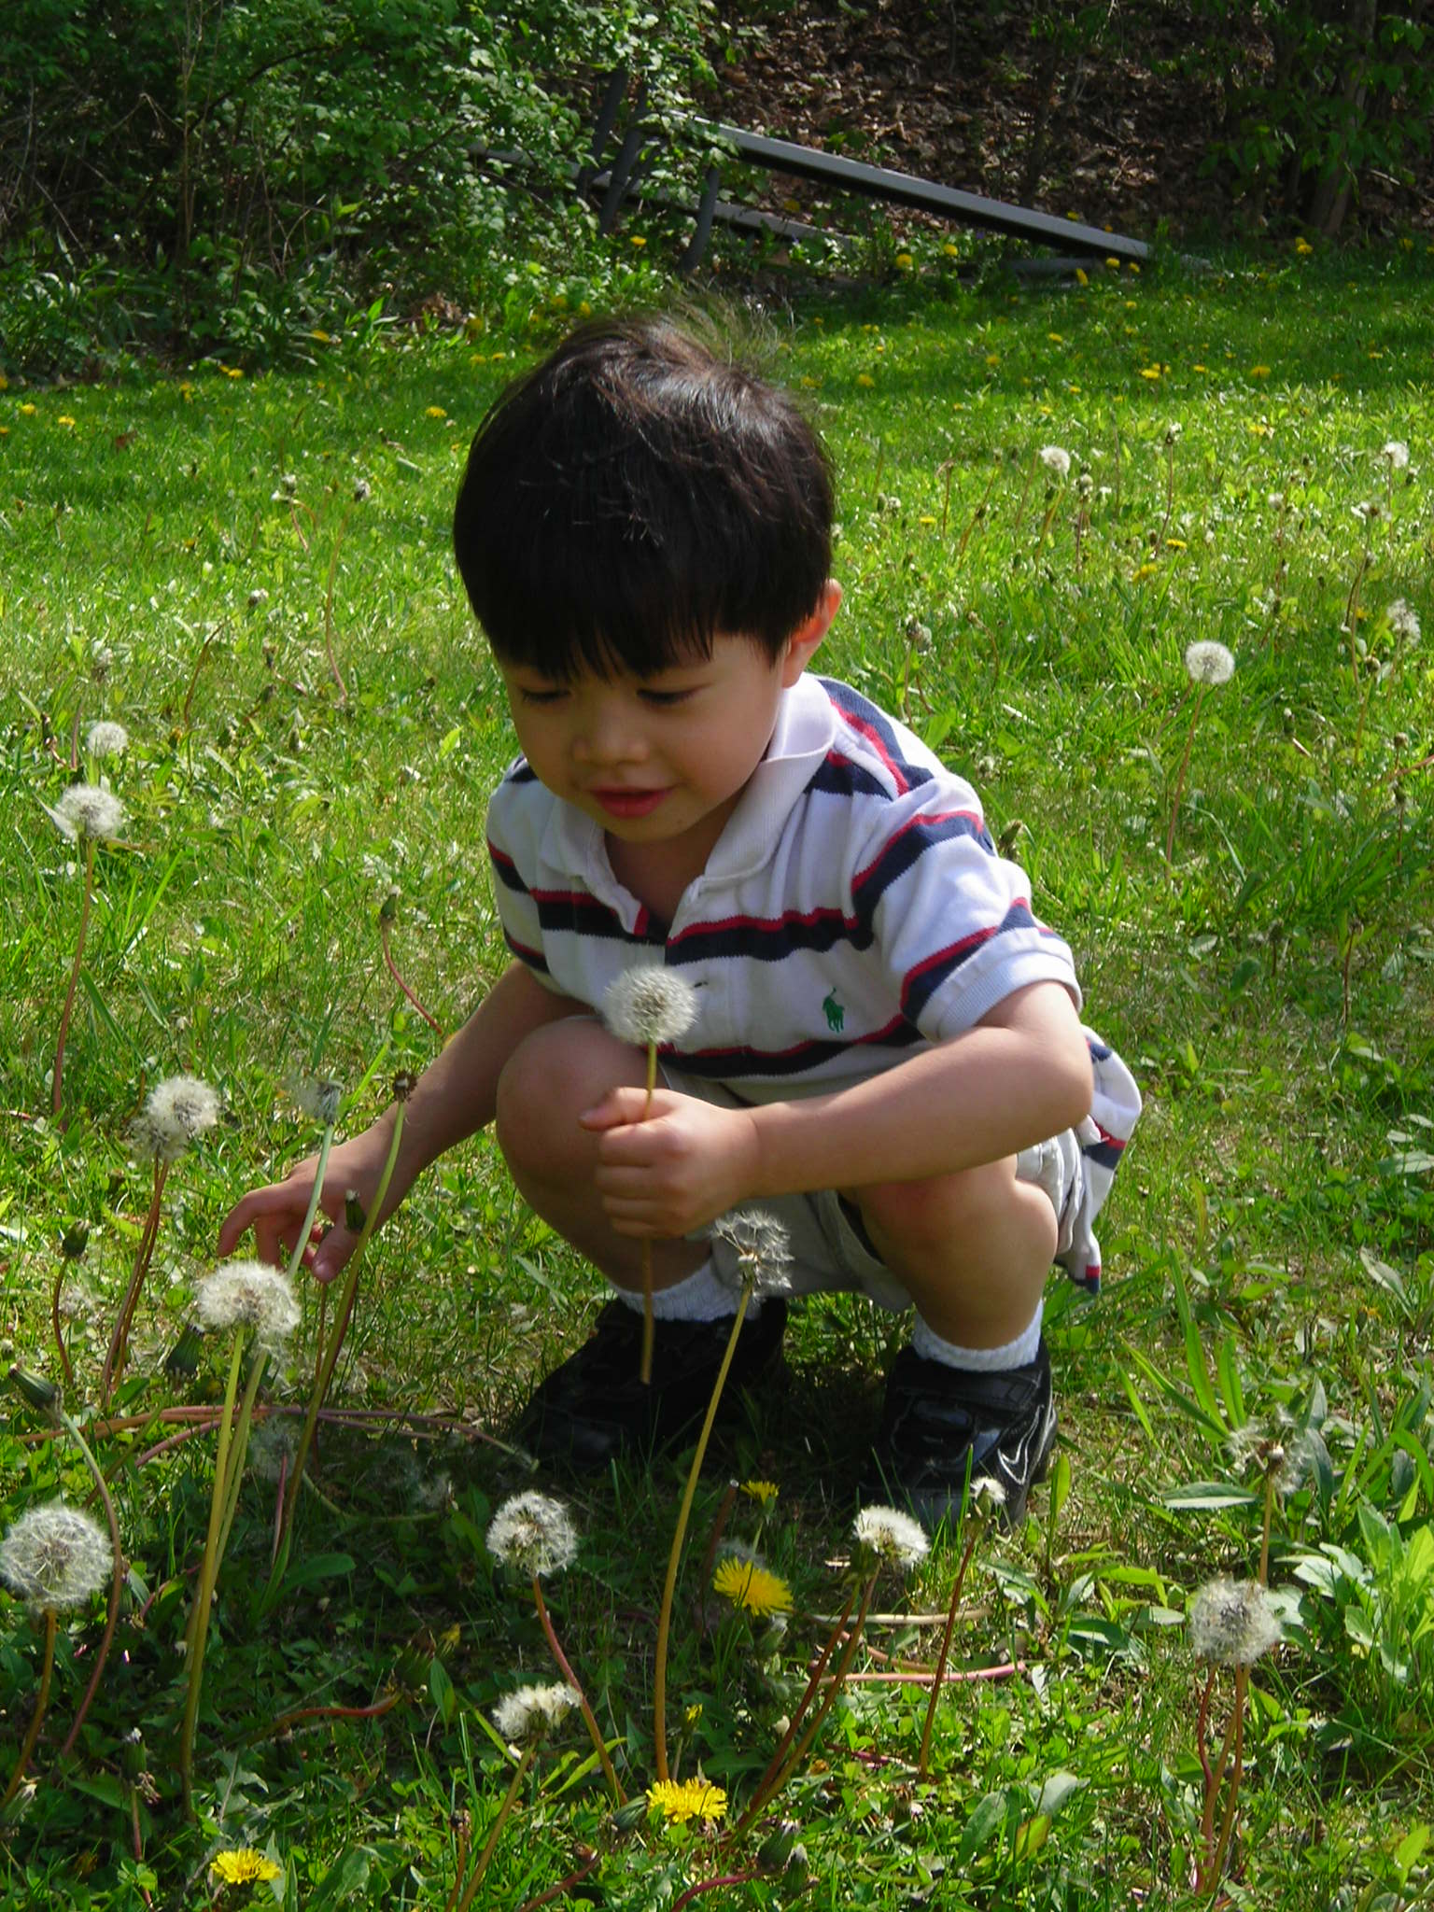
Philosophy.
UPC Discovery Early Learning Center provides a nurturing, safe, and stimulating learning environment. We believe children learn best when actively engaged in the classroom and when their curiosity is supported through project work. Parents are partners on the learning journey and contribute much to the early childhood classroom. As teachers support and nurture their students, document their learning, and partner with parents, they model Christian values and represent United Presbyterian Church in the community.

Program Goals
The following goals provide guidelines for developing our program. Your child will:
- develop to their fullest potential in all learning domains
- develop the ability to deal effectively with the environment
- learn to stay on task and persevere
- learn to be actively engaged in the learning process
- learn to take risks in the learning process
- develop self-confidence and an appropriate level of independent decision making
- develop a knowledgeable, confident self identity
- develop comfortable, empathetic interactions with all people
- participate in religious education through developmentally appropriate activities

Children with Special Needs
UPC Discovery Early Learning Center encourages children of all backgrounds to attend our programs. We do not discriminate on the basis of gender, religion, or ethnic background. When in the best interest of the child, children with special needs are welcomed into our program. We believe children benefit from a variety of experiences with children who may be different from themselves. Our learning community may include children with physical, cognitive, or developmental challenges.

USE OF SPECIALIZED CONSULTANTS
On occasion, and when appropriate, staff may need to consult with resource personnel outside the program about a child. Parents will be a part of this process and are encouraged to collaborate with the classroom teachers and the specialized consultants to identify challenges and solutions. Parent permission forms must be completed before consultation services can begin.

Toileting Policy
Children enrolled in our preschool program are required to be potty trained.
Children enrolled in our toddler program are not required to be potty trained and teachers will reflect home practices when working with our toddler students on potty training.

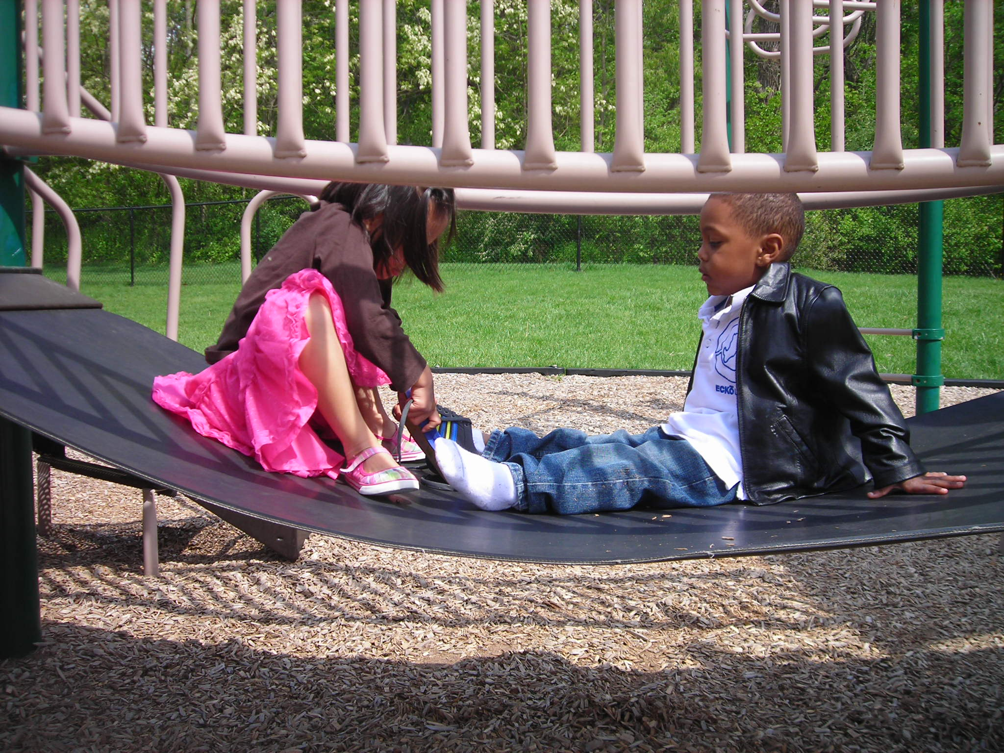

Behavior Expectations
Children are entitled to a pleasant and safe environment in their classroom at UPC Discovery. When a child persistently exhibits negative behaviors or functions at a significantly lower developmental level than most children, the environment, schedule, or activity level of the classroom may be a challenge and UPC Discovery is not the best educational placement for the student. In order to best serve all children, UPC Discovery cannot serve children who display chronically disruptive behavior or children who have been determined to be significantly delayed developmentally. Chronically disruptive behavior is defined as verbal or physical activity which may include but is not limited to such behavior that: requires constant attention from the staff, inflicts physical or emotional harm on other children, abuses the staff, ignores or disobeys the rules which guide behavior during the school day and program time. Negative or unhealthy behaviors such as spitting or any behaviors which endanger the child (such as leaving the building) will not be accepted. If a child cannot adjust to the program setting and behave appropriately, the child may be discharged. When three incidents of the behaviors listed above are documented, the student will face dismissal from the program. Significant developmental delays include: children who function at a much lower level than a typically-developing child and exhibits the following challenges at a severe level: verbal and written communication, toilet training, attention span, and the ability to interact with other children.

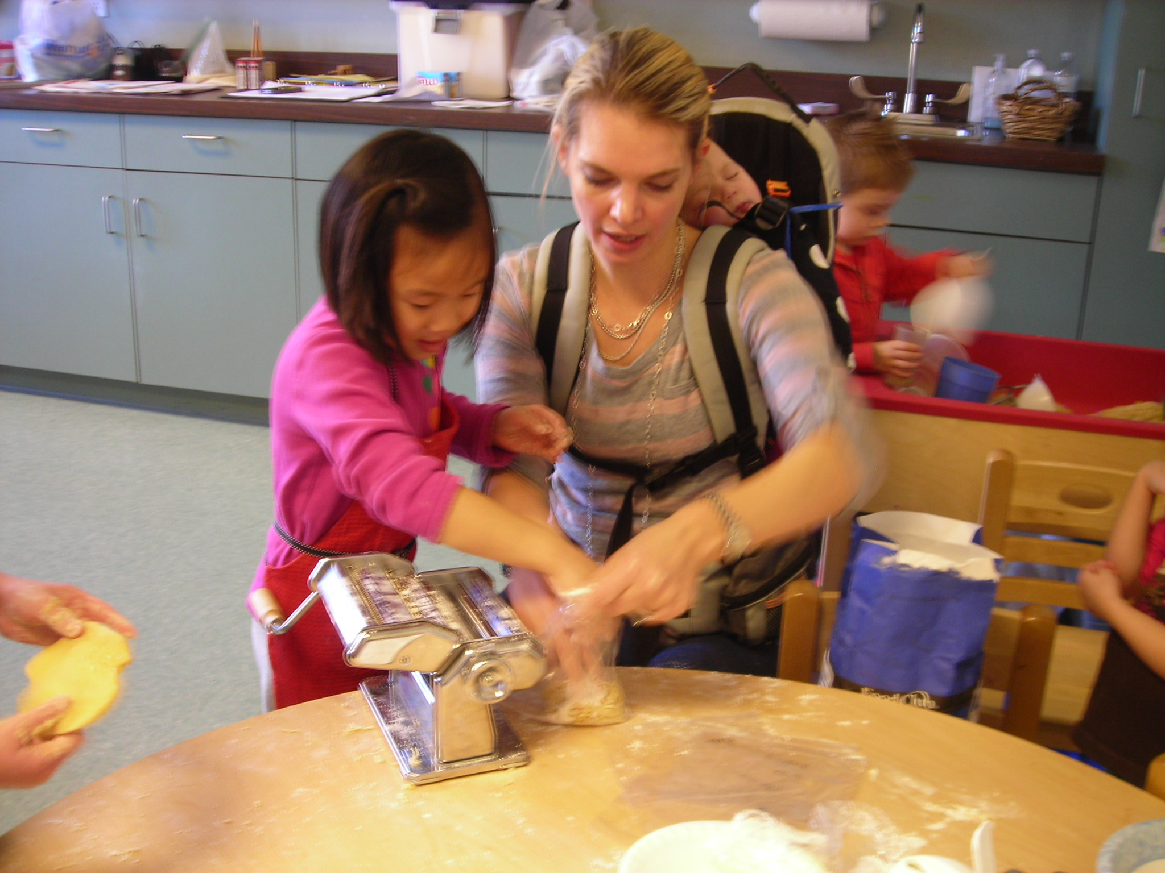

Parent Involvement
We encourage our families to become actively involved in UPC Discovery. Please plan for you or a family member to visit/volunteer in your child’s class at least once each semester. Each year we hold scheduled family nights to strengthen the link between home and school and we encourage our families to attend all these events. We are looking forward to becoming partners in your child’s learning journey.

Home visits are scheduled in August before the first day of school and serve to build relationships between home and school. Teachers personally call each family to schedule a convenient day and time. Parent/Teacher conferences are held twice per year, once in the Fall and once in the Spring and serve as an opportunity for parents and teachers to share about their child’s development in the classroom. If needed, efforts will be made to provide interpreters for families where English is the second language.

As we provide a well-rounded learning experience, it is difficult to make holidays meaningful for very young children. Most holidays are based on concepts that are beyond your children’s understanding. Often, holidays are extremely overdone. Children see signs of the major commercialized holidays everywhere, so they ask questions and families make choices. Within your family, you have the opportunity to involve your child in aspects of a holiday you feel are in keeping with your family’s beliefs, values, and traditions. We feel it is more effective to expose children to information and activities that you might not have the time or resources to facilitate as a family.

At UPC Discovery we constantly evaluate how we will spend our time, energy, resources, and how we will meet our curriculum goals. As a staff, we are committed to investing time in meaningful experiences, consequently we will not celebrate secular holidays, such as Halloween and Valentine’s Day, but instead encourage you to celebrate holidays as you desire.
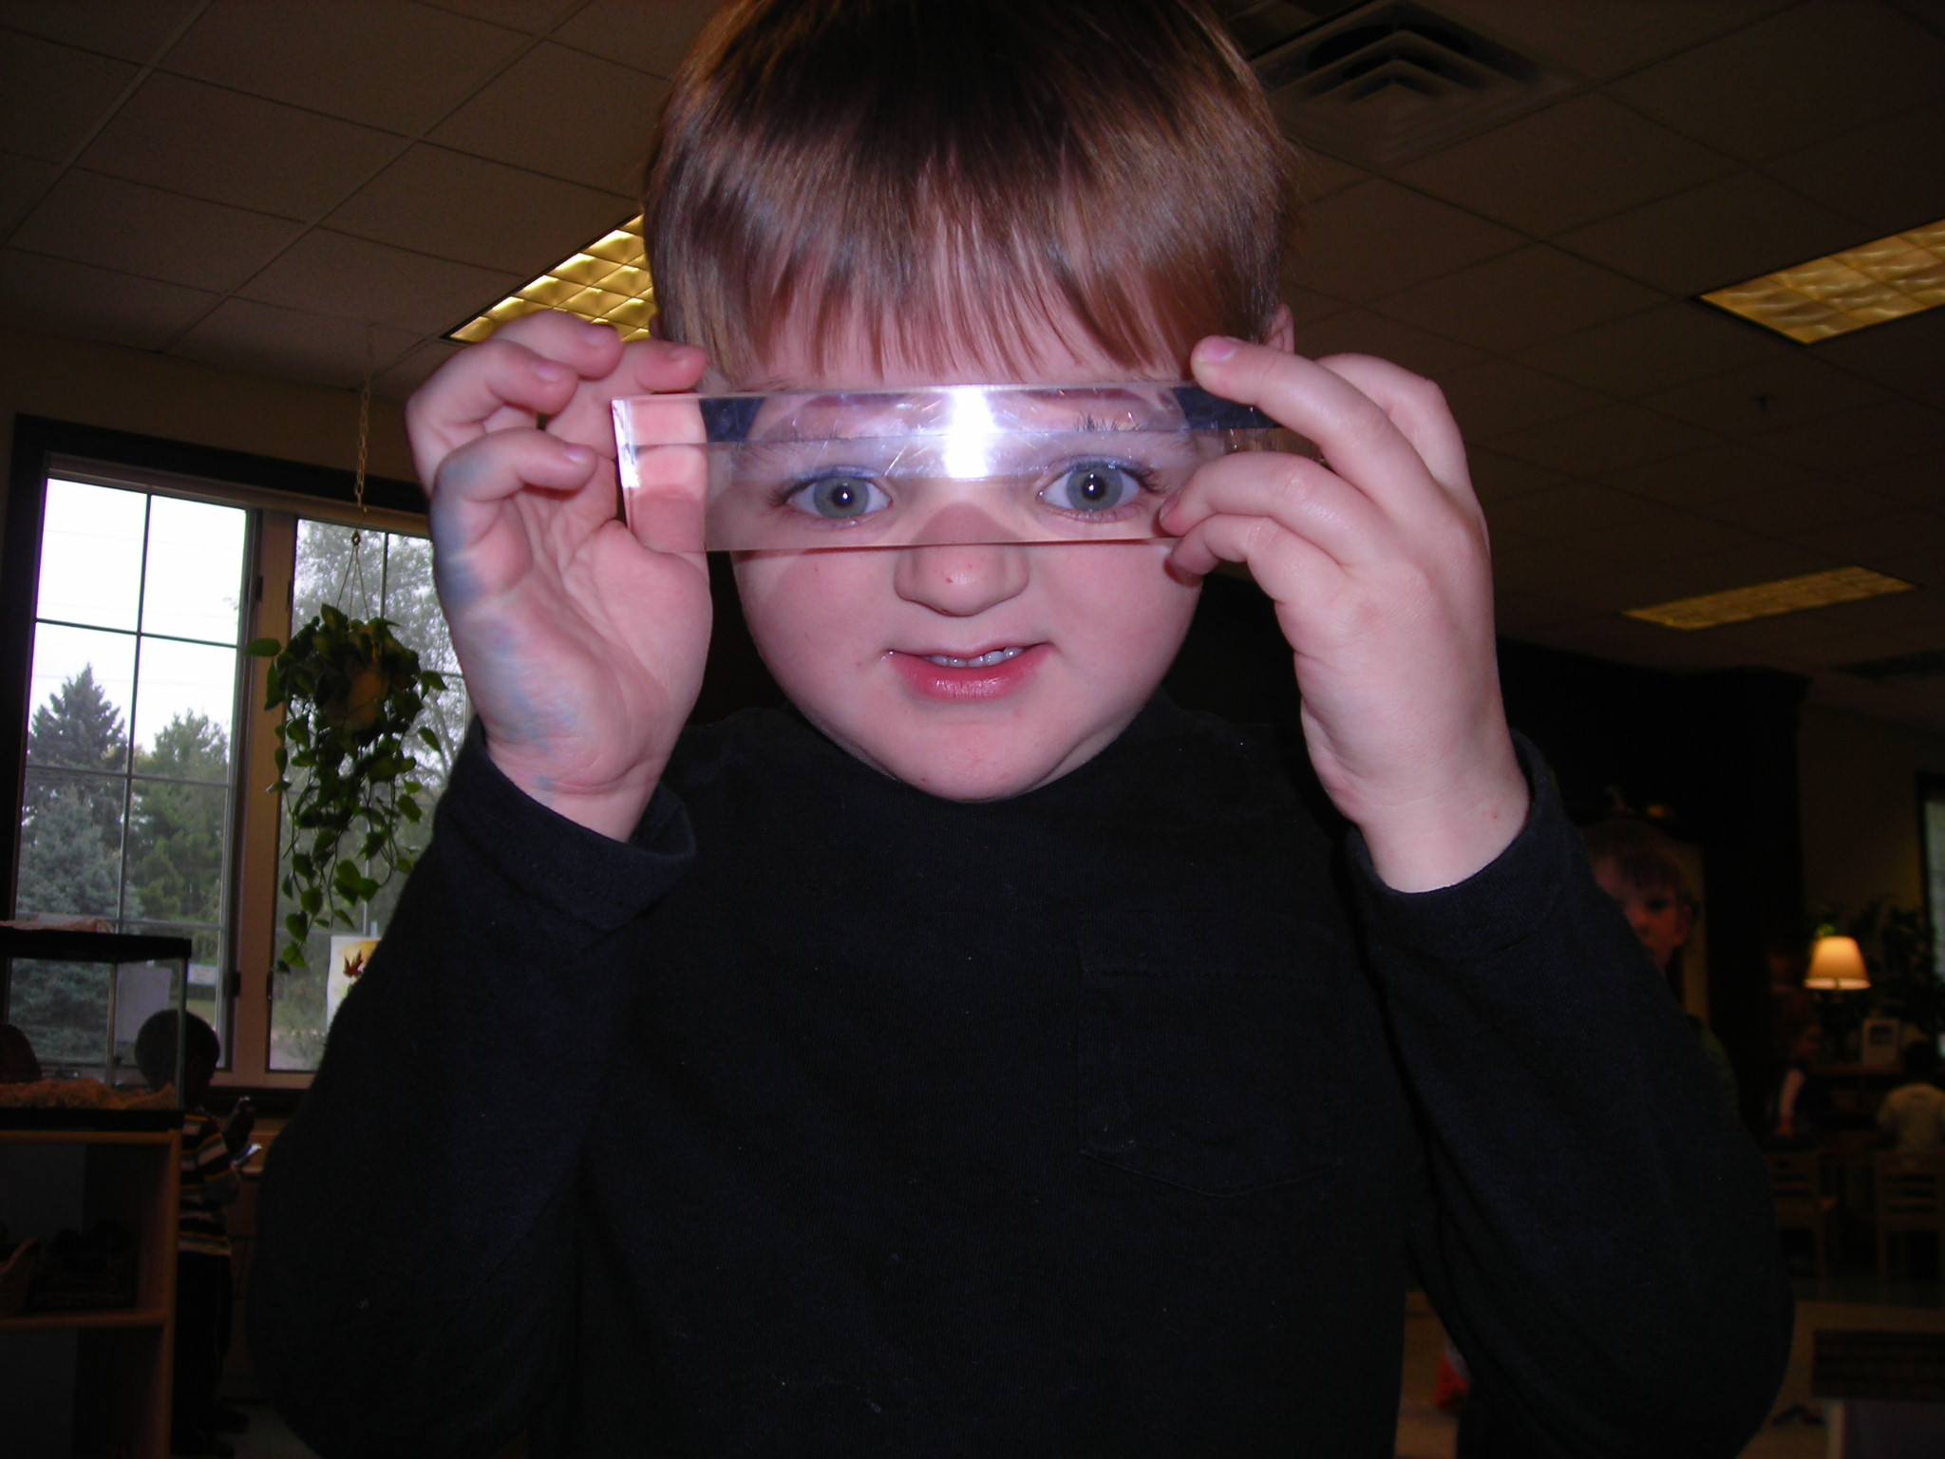

Enrollment and Discharge Policy
To enroll, a completed registration application and a $100.00 registration fee must be submitted to the director. If all the child’s required enrollment forms are not completed and returned to the director by the day the child is scheduled to start the program, the child will not be allowed to attend until these completed forms are submitted. In order to be eligible for priority enrollment, your child must be currently attending and participating in a classroom at UPC Discovery. In addition, you must be financially current.

The parent/guardian will be responsible for payment of fees in order to reserve the enrollment spot until such time as the completed forms are returned. If classes are full, the child’s name will be placed on a waiting list and the registration fee returned.
Enrollment is complete when all necessary forms have been completed and returned to the director, along with the registration fee and first month’s tuition.

Any child who does not meet the behavior policy, cannot benefit from our program, or whose presence is detrimental to the other children and program, shall be dismissed by the director.

Parents who fail to call in to excuse their child’s absence more than five times may be dismissed from the program. Children missing more than 15 days of school may also be dismissed from the program.

Calendar
Upon enrollment, you will receive a calendar listing evening events, parent teacher conferences, and school holidays. We follow a modified Dunlap District 323 school calendar when determining the days school will not be in session.

IF Dunlap District 323 HAs CALLED OFF SCHOOL,
UPC Discovery WILL BE CANCELED.

Our school year begins the Tuesday after Labor Day and ends on Thursday, May 21, 2020.

Snack.
A snack and water will be provided during each class session. If you would like to provide a healthy snack, you are welcome to sign up on the snack calendar located on the parent bulletin board outside the classroom. Per DCFS, all snacks must be commercially prepared. Due to numerous allergies, snacks containing peanuts and peanut butter will not be served.
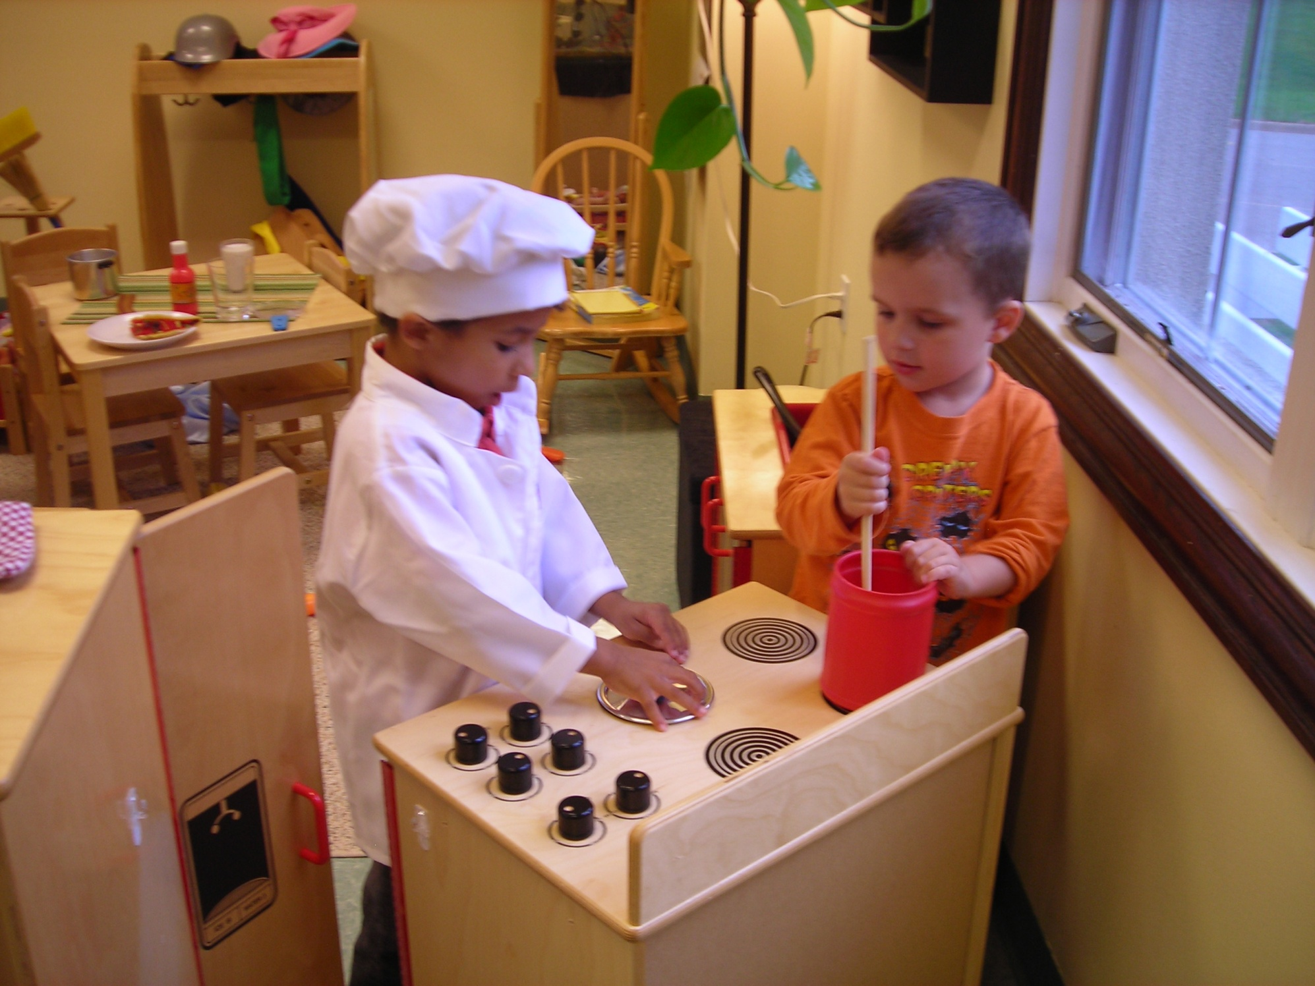
Lunch
For children enrolled in our full day preschool program, a nutritious lunch will be served every day and is included in the tuition payment at no extra charge. Lunch menus will be distributed at the beginning of each month. Children will be served family style by UPC Discovery staff. A certified cook will prepare and oversee the lunch program. Children in full day preschool will brush their teeth after lunch, before rest time period each day. No toothpaste will be used.

Health Examinations
Each child is required to a have a physical exam record including immunizations in their enrollment folder. A child where documentation shows under-immunization status must have documentation on file by a licensed health professional that states the reason for under-immunization status and acknowledgment. A child’s physical must be less than 6 months old. Children returning to the program as four-year-olds are not required to get a new physical. A lead screening (or waiver) and TB test (or waiver) must also be included.


Birth Certificate Requirement
(As required by the Dept. of Children and Family Services 407.250)

Beginning in the fall of 2010, all families will be required to prove a certified copy of their child’s birth certificate or other reliable proof of identity and age within 30 days of enrollment. If a certified copy of the birth certificate is not available, the parent or guardian must submit a passport, visa or other governmental documentation as proof of the child's identity and age and an affidavit or notarized letter explaining the inability to produce a certified copy of the birth certificate. UPC Discovery will accept a copy or will duplicate and return the original certified copy to the parent or guardian no later than the end of the next business day after receipt.

UPC Discovery is now required by law to notify the Illinois State Police or local law enforcement agency if the parent or guardian fails to submit proof of the child's identity within the 30 day time frame. Additional steps and guidelines regarding failure to adhere to this policy can be found at http://www.state.il.us/DCFS/docs/407.pdf.

A confidential file of each individual child that contains the documents described above, as well as enrollment forms will be kept in a secure cabinet and locked. Teachers, parents, and the program director can access the files when appropriate.

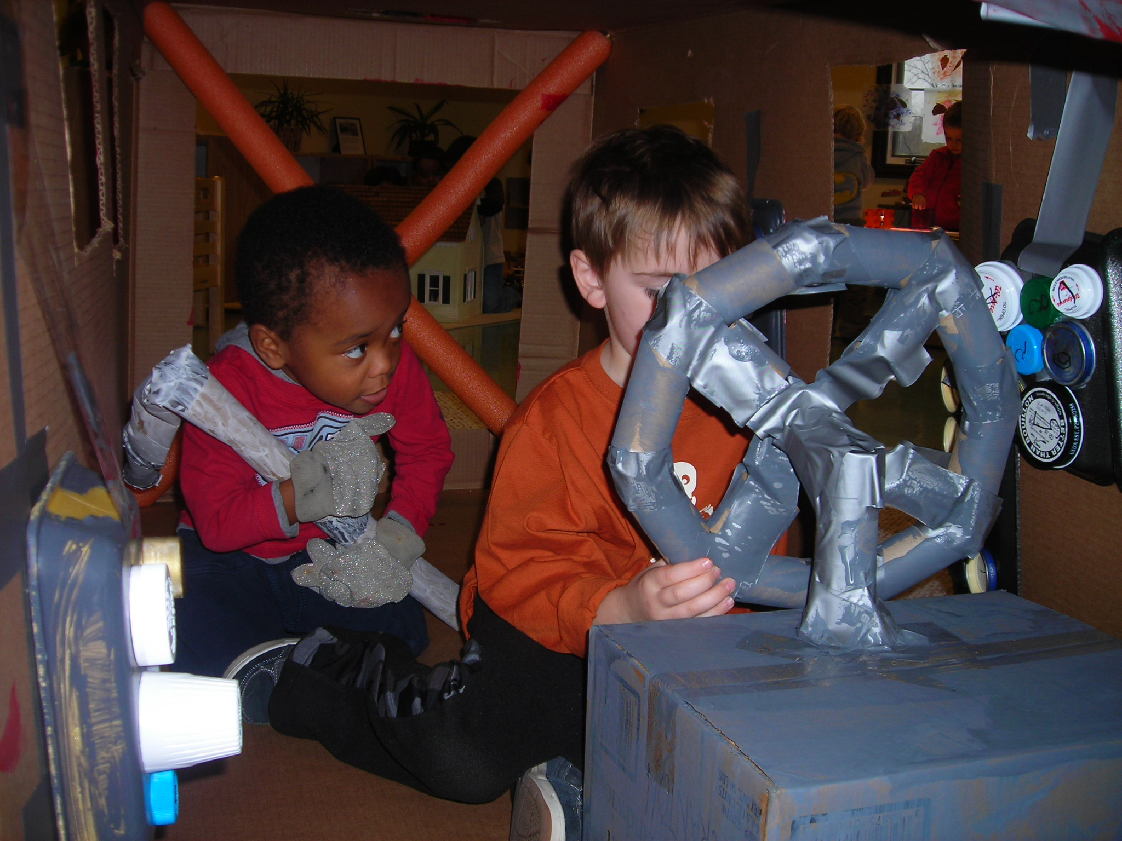

Drop Off / Pick Up
Parents need to park in the lot and bring their child into the building. Parents are expected to drop children off at the classroom door after helping children hang up their coat and bag. Parents need to stop at the restroom and help their children wash their hands before entering the classroom. Taking children to the classroom assures safety of students and provides parents an opportunity to visit with the classroom teachers on a daily basis.

You may drop children off five minutes before class begins. Parents picking up more than five minutes late will be assessed a $5.00 late fee. If a parent has not contacted the program 15 minutes after the end of class, the staff will begin calling emergency contacts. The staff will make a minimum of three phone calls to emergency contacts in order to arrange for someone to pick up your child. Without success of finding a contact person who will take your child home, the police will be called. After an hour, if your child is still at UPC Discovery and no one is available to care for him or her, your child will be placed in the custody of the police. In order to avoid this very disturbing situation, it is critical for parents to contact the program if they are going to be late and to make sure a child’s emergency contact information is always current and correct. Please be assured that while your child is here, UPC Discovery staff will continue to provide care and will reassure the child that he or she is safe and that everything will be okay. The child will never be held responsible for his/her parents’ tardiness and the issue will always be discussed with the parent and not the child.

After Care Program Tardy Policy
Parents arriving late, (after 5:30 pm), to pick up their child from the aftercare program will incur a late fee of $20 for the first five minutes, and $10 for every five minutes after. Late arrival payment will be made directly to the aftercare teacher at that time.



Health & Safety/Absence & Illness
In the event that your child is ill, please refrain from bringing him/her to the program. Children who are obviously ill or who have a temperature will not be allowed to stay at the program. Keeping your child home when they are ill allows your child to be more comfortable and helps prevent the spread of illness. You must call when your child will be absent. (309-693-7296)

If your child is unable to attend class for any reason, we will not reimburse you for that day. Each day of class we plan on your child attending and schedule staff and purchase materials accordingly. Children will not be able to make up missed days because our classes would exceed capacity.

If your child exhibits any of the following symptoms or illnesses, please keep them home from school.
1. Children with diarrhea and those with a rash combined with fever (oral temperature of 101 degrees Fahrenheit or higher or under the arm temperature of 100 degrees Fahrenheit or higher) shall not be admitted to the Learning Center while those symptoms persist. Children shall be removed as soon as possible should these symptoms develop while the child is at the center.
2. Children need not be excluded for a minor illness unless any of the following exists, in which case exclusion from the Learning Center is required:
- Illness which prevents the child from participating comfortably in program activities
- Illness which calls for greater care than the staff can provide without compromising the health and safety of other children
- Rash combined with fever over 101 degrees Fahrenheit (oral)
- Unusual lethargy, irritability, persistent crying, difficulty breathing or other signs of possible severe illness
- Diarrhea
- Vomiting two or more times in the previous 24 hours, unless the vomiting is determined to be due to a non- communicable condition and the child is not in danger of dehydration
- Mouth sores associated with the child’s inability to control his or her saliva, until the child’s physician or the local health department states that the child is noninfectious
- Rash with fever or behavior change, unless a physician has determined the illness to be non-communicable
- Purtilent conjunctivitis, until 24 hours after treatment a. has been initiated
- Impetigo, until 24 hours after treatment has been initiated
- Strep throat (streptococcal pharyngitis), until 24 hours after treatment has been initiated and until the child has been without fever for 24 hours
- Head lice, until the morning after the first treatment
- Scabies, until the morning after the first treatment
- Chicken pox (varicella), until at least six days after onset of rash
- Whooping cough (pertussis), until five days of antibiotic treatment have been completed
- Mumps, until nine days after onset of parotid gland swelling
- Measles, until four days after disappearance of the rash
- Symptoms which may be indicative of one of the serious, communicable diseases identified in the Illinois Department of Public Health Control of Communicable Diseases (77 III. Adm. Code 690)

3. Space shall be provided for a child who becomes ill at the center. Such space shall be ventilated and heated, within sight and hearing of an adult and equipped with a cot and materials that can be easily cleaned and sanitized.
4. The center shall report any known or suspected case or carrier of communicable disease to local health authorities and comply with the Illinois Department of Public Health’s Control of Communicable Diseases Code (77 III. Adm. Code 690).
5. If a child needs emergency care because of an accident or illness that occurs while the child is in care, the center shall attempt to contact the child’s parent(s) at the phone numbers provided for that purpose. If unable to locate the parents, the UPC Discovery staff’s attempts to do so shall be documented in the child’s file.
6. Major and minor accidents or illnesses which happen to a child at UPC Discovery shall be recorded in file, and parents shall be notified.

In case of accident or illness, parents of the child will be called immediately. In serious cases, the child will be taken to one of the local hospitals by emergency vehicle for treatment and the parents will be called as soon as possible.

Medication at School
Children requiring medicine during the school day are required to have a doctor’s note, with written instructions and dosage on file for any medications, including over-the-counter medications, (Tylenol, Bendryl, etc). Children will be brought to the director’s office and given the medication as directed by the doctor. A medicine log will be filled out each day to document times and dosage given. All medications are kept in a locked file cabinet in the director’s office.
During warm fall and spring days children should come to school with sunscreen already applied. If your child needs a second application, parents should provide the brand used at home for their child. Teachers will keep individual sunscreen containers in the locked cabinet labeled with each child’s name. During months when insects are present and there is high risk of insect-borne disease, children should come to school with insect repellent containing DEET already applied.

OUTDOOR POLICIES
Because of our core value in connecting children with the nature, we spend long, uninterrupted time outside. Children need to be dressed appropriately for the weather each day: dressing in layers when it’s cold, wearing sun hats and sunscreen when it’s warmer, bringing cold weather gear like boots, mittens, hats, and coats to play outside in the snow, and always making sure children have a warm change of clothes in their backpack.

Food Allergies
UPC Discovery is a peanut-free environment. No foods containing peanuts will be served to children. Efforts are made daily to limit contact with other food allergies, (dairy, gluten, etc), by asking children to wash their hands before entering the classroom for school. If your child has severe food allergies, extra measures will be taken to ensure their safety at school. In some cases, families will be asked to provide foods that are safe for their children to eat. It is always best to err on the side of safety and check the snack/lunch menu weekly.

Pesticide Policy
(As required by the Dept. of Children and Family Services 407.370)

United Presbyterian Church has contracted with a local pest control company. Every month a technician comes to the church to evaluate any pest issues the church may have. Typically the visits occur at the beginning of each month. UPC Discovery takes preventative measures including daily classroom cleaning and trash removal to provide a safe, clean environment for our children and staff. If you wish to receive a notification of intended date of application of the pesticide, one will be provided upon your request.

Guidance Procedures
Our philosophy, in addition to the laws of the state of Illinois, prohibits physical punishment. We guide children’s behavior positively by creating a supportive environment that:
- Focuses on children’s strengths
- Encourages adults to form positive, authentic relationships with children
- Makes a commitment to supporting child’s play
- Offers plenty of opportunity for children to make meaningful choices
- Uses re-direction as a guidance technique
- At times, ignores inappropriate behavior
- Has a consistent, yet flexible daily routine
- Provides for both active and quiet times
- Uses positive key phrases to guide children’s behavior
- Offers respectful reminders
- Acknowledges each child’s individual needs
- Is aware of each child’s developmental stage
- Adopts a problem solving approach to conflict
- Has age appropriate expectations
- Allows expression of feelings and emotions

Families will be informed on a regular basis as to their child’s success in the classroom. If your child is struggling, we will invite you to share more about your child and his behavior at home. Together we will work to ensure your child’s success.

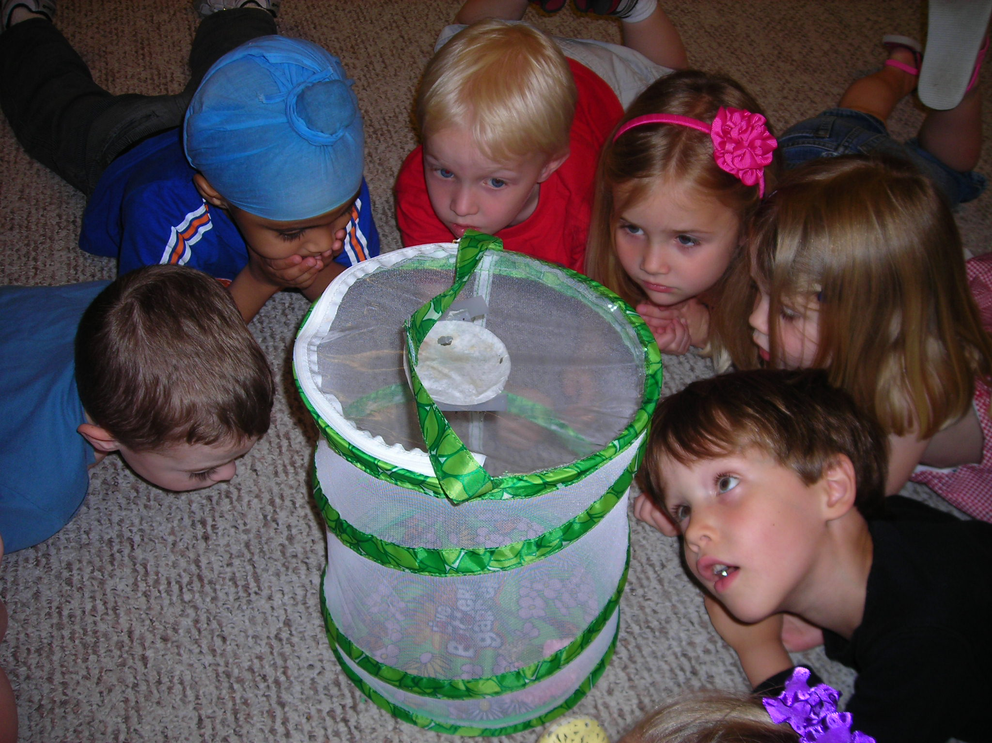

Hours Of Operation
UPC Discovery offers part day morning preschool sessions - from 8:30 - 11:30. Half day preschool classes run Monday-Thursday. Full day preschool is in session Monday – Friday from 8:30 am to 3:30 pm. A pre care option is available from 7:00 to 8:20 each morning and an after care option is available every afternoon from 3:30 to 5:30.
Our toddler program offers two day sessions: Monday/Tuesday or Wednesday/Thursday and classes run from 8:45 to 11:15 each day.

Please use the phone number: 309-693-7296 or the director’s email: lora.taylor@upcdiscovery.org to contact with any issues or concerns. Individual teachers will share their contact information during Parent Orientation.

Classroom Video Camera
An Internet video camera has been setup in the classroom so that parents can view their child’s preschool class in session. UPC Discovery has taken several precautions to enhance security:
- The camera has an obscure web address
- The camera is protected with a username and password
- Parents should not reveal usernames and/or passwords to anyone, doing so will compromise security
- Passwords are changed periodically
- The camera does not record video

Parents are required to sign a form allowing use of the camera in the classroom.

Fees
½ Day Preschool Tuition is $215 per month/$210 for UPC members
Full Day Preschool Tuition is $585 per month
Pre Care option is an extra $75 per month
Post Care option is an extra $100 per month
Toddler Tuition is $160 per month

In order to keep costs down, families are offered two options for tuition payment. You may choose to have tuition automatically deducted from your bank as an Electronic Funds Transfer (EFT).

Tuition is withdrawn around the 6th of each month, beginning in October and ending in May. This method of payment is convenient and will alleviate the possibility of late fees.

Parents may also choose to pay tuition by credit card, but this method will require an additional charge of 4% per tuition fee per month.

A child attending any part of a given month will be required to pay for that month. You are responsible for tuition fees even when you choose not to send your child due to family vacations, illnesses, etc. If your child is leaving the program, a written statement must be submitted at least two weeks prior to the withdrawal date.

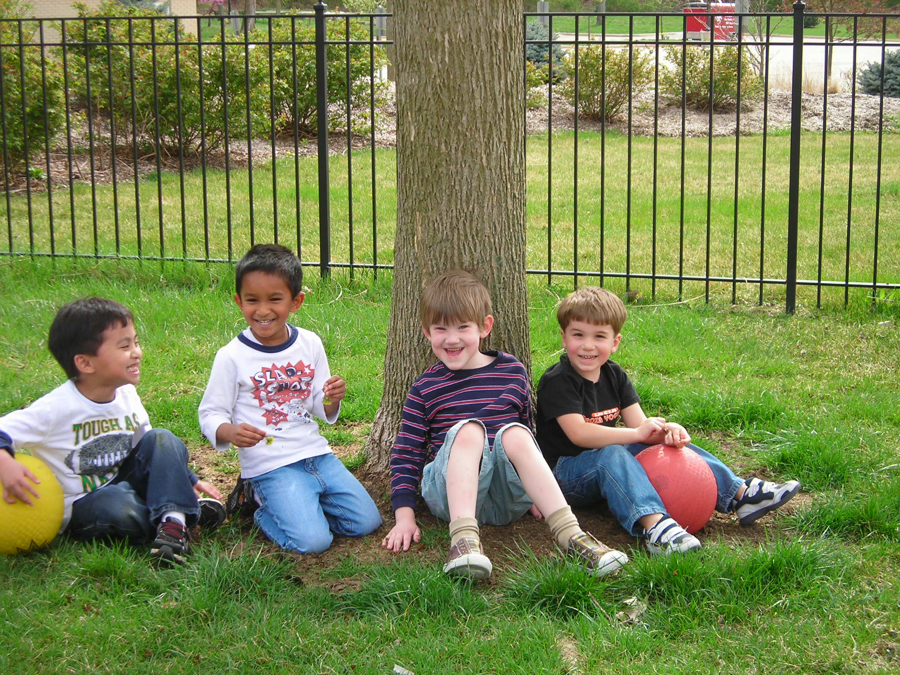

1/2 Day Preschool Daily Classroom Schedule (times may vary)
8:30 – 8:35 Book Time on the Meeting Rug
8:35 – 8:45 Greeting / Jobs
8:45 – 9:45 Learning Centers / Projects
9:45 – 10:00 Music / Creative Movement
10:00 – 10:15 Snack
10:15 – 10:30 Shared Reading
10:30 – 11:00 Gross Motor / Outside Time
11:00 – 11:15 Small Learning Groups
11:15 – 11:30 Godly Play

Full Day Preschool Daily Classroom Schedule (times may vary)
8:30 Book Time on the Meeting Rug
8:40 Greeting / Classroom Jobs
9:00 Small Groups
9:15 Learning Centers
10:20 Music / Creative Movement
10:40 Snack
11:00 Shared Reading
11:30 Gross Motor / Outside Time
12:00 Lunch
12:45 Rest Time
2:00 Story Time
2:15 Snack
2:40 Godly Play
3:00 Gross Motor / Outside Time
3:20 Daily Message / Goodbye Song

Toddler Daily Classroom Schedule (times may vary)
8:45 – 9:00 Handwashing, greeting, Good Morning Song
9:00 – 10:00 Learning Centers / Projects
10:00 – 10:30 Outside Time
10:30 – 10:45 Music Time
10:45 – 11:00 Snack
11:00 – 11:15 Storytime / Goodbye Song

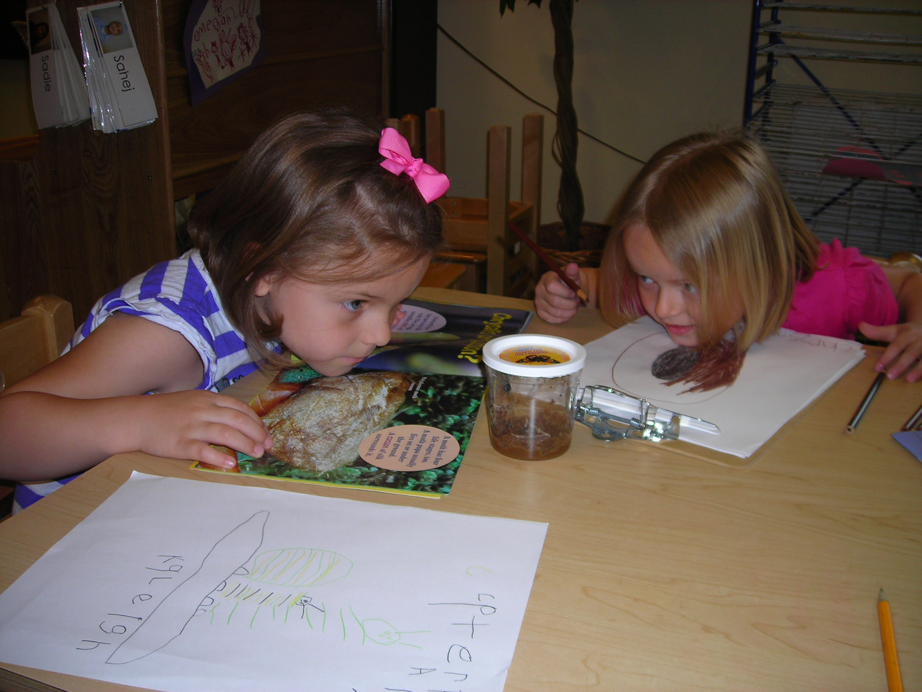

Curriculum

The Program

UPC Discovery engages children’s minds through active and investigative play, their hearts through faith-based activities and Godly Play, their curiosity through nature activities and inviting nature into the learning environment, and their imaginations through music, drama, and the visual arts. Our Reggio Emilia inspired environment is structured so our curriculum is child initiated and teacher facilitated.
Children identify what they want to learn more about: flowers, ladybugs, emotions, medicine, reptiles, snowflakes, or anything else that captures their interest and imagination. Teachers help children ask good questions and guide them to discover the answers for themselves. Teachers also use the classroom and outdoor environments to provoke new experiences and inspire learning. Sometimes children go out into the world to discover more about the topics they choose and sometimes the world is brought into the classroom. If the children want to learn more about the weather a meteorologist might visit, the children may go outside in different types of weather and then discuss how each different type of weather made them feel, then they may draw pictures of their favorite type of weather and sing songs about the weather, and they can do science experiments where they can create rain in a 2-liter soda bottle.
Highly trained teachers facilitate and document children’s discoveries in order to assess with parents how their child is meeting Illinois Early Education Standards. As the school year progresses, the walls are covered not only with the children’s work, but their teachers’ documentation of the children’s thoughts, ideas, and growth through their projects. Teachers provide parents with written documentation of daily life in the classroom using a notebook dedicated to each student filled with samples of work, photos of play, and videos of discovery.

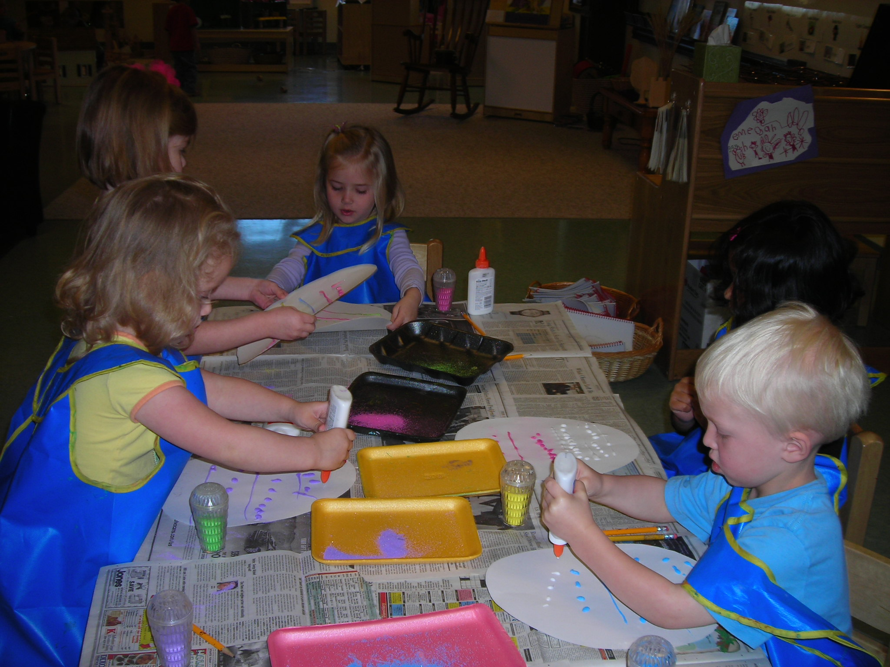

Play Based Learning
Play is essential to children and makes learning active rather than passive. Play provides opportunities for children to learn and grow physically, cognitively, and socially. Children explore, create, experiment with new ideas, and make new discoveries by trying out what they have learned. What a child learns while playing is the basis for what they will learn later in elementary school.
Our program is enhanced by a stimulating environment both indoors and outdoors which invites children through self-directed play to think, wonder, question, problem solve, and learn through their playful interactions (discoveries) with their environment. Children learn through play so every experience is an opportunity to learn.
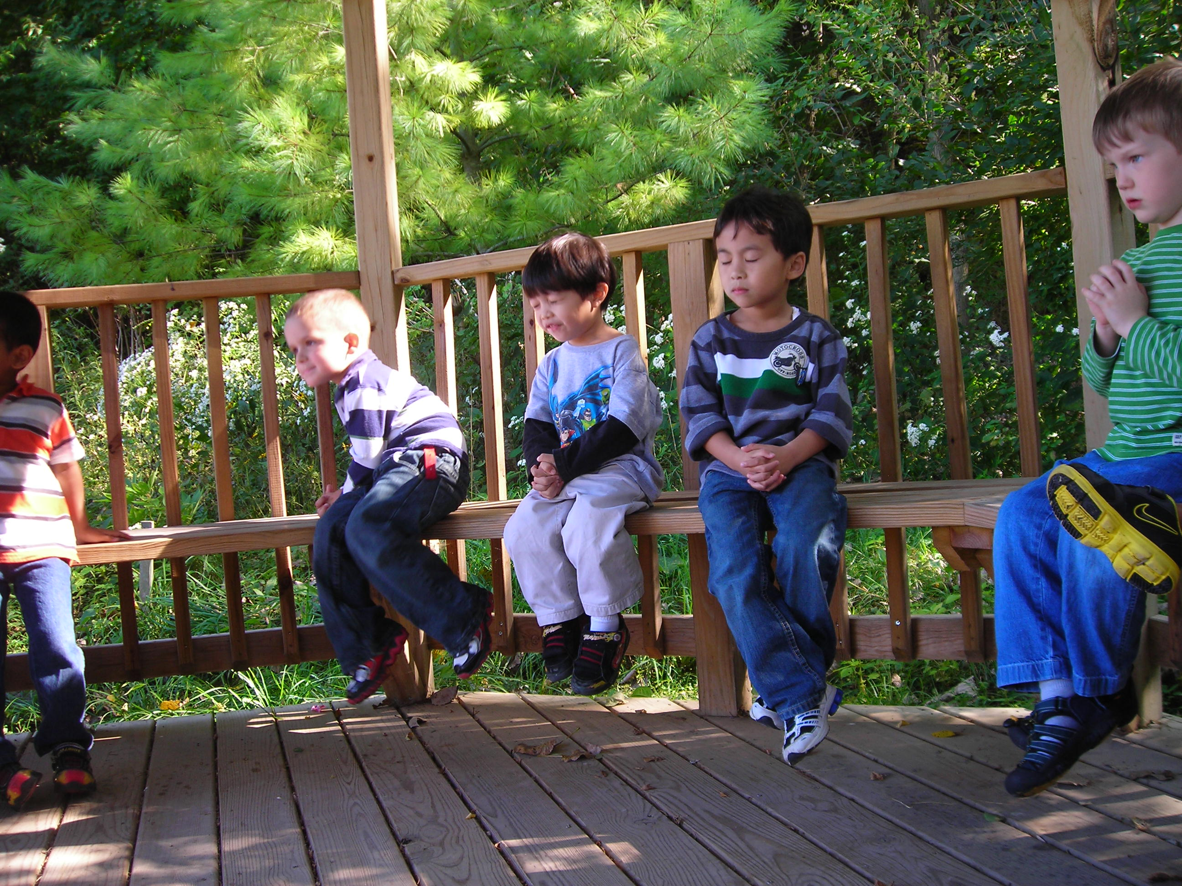

Faith Based Learning

At UPC Discovery children are introduced to faith through modeling, play, and faithful interaction while immersed in faithful environment. We use Godly Play and other faith-based activities which invite children into Biblical stories so they can discover the meaning and message of the faith principles in the story and make connections to their daily life.
Children learn faith principles in Godly Play and further explore those through drama, music, and the visual arts. Children may hear about the Mary and Joseph’s journey to Bethlehem and then play “Road to Bethlehem” with costumes and props, draw a picture of Mary and Joseph travelling to Bethlehem, or sing a song and play instruments along with the music. Children participate and interact in Bible stories which leads to living out Biblical principles.

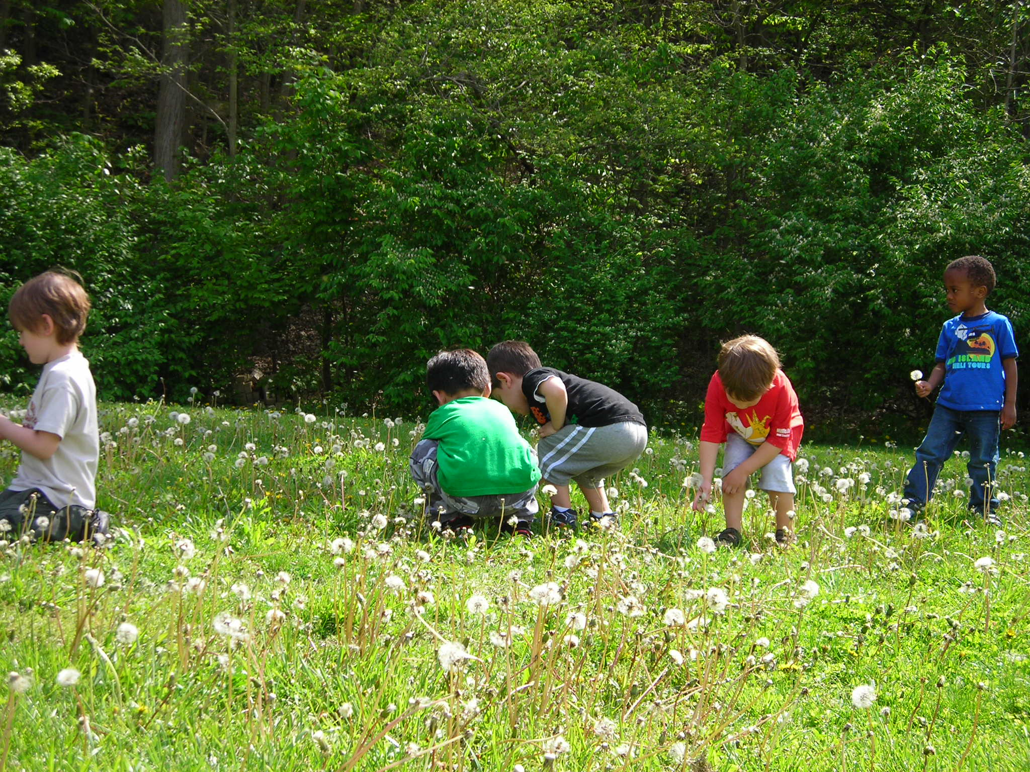

Nature-Based Learning

Children today spend less time outside exploring and discovering in nature and more time indoors in front of screens. Allowing children to play outside, manipulate natural materials, and discover a living world builds self-esteem, critical thinking, and creative inquiry. By taking children out into nature and bringing nature into the classroom, children gain a better appreciation for the world around them. A deeper understanding of the natural environment helps children to appreciate that they are part of a larger world, and to recognize and value their place in it.
Children at UPC Discovery are able to enjoy a large outdoor playground with plenty of green space and are able to explore the church grounds with their teachers. The grounds of United Presbyterian Church are an official National Wildlife Habitat with many distinctive species of flowers and trees. Children can even see families of geese and ducks roost in the spring and may see the occasional deer or wild turkey.
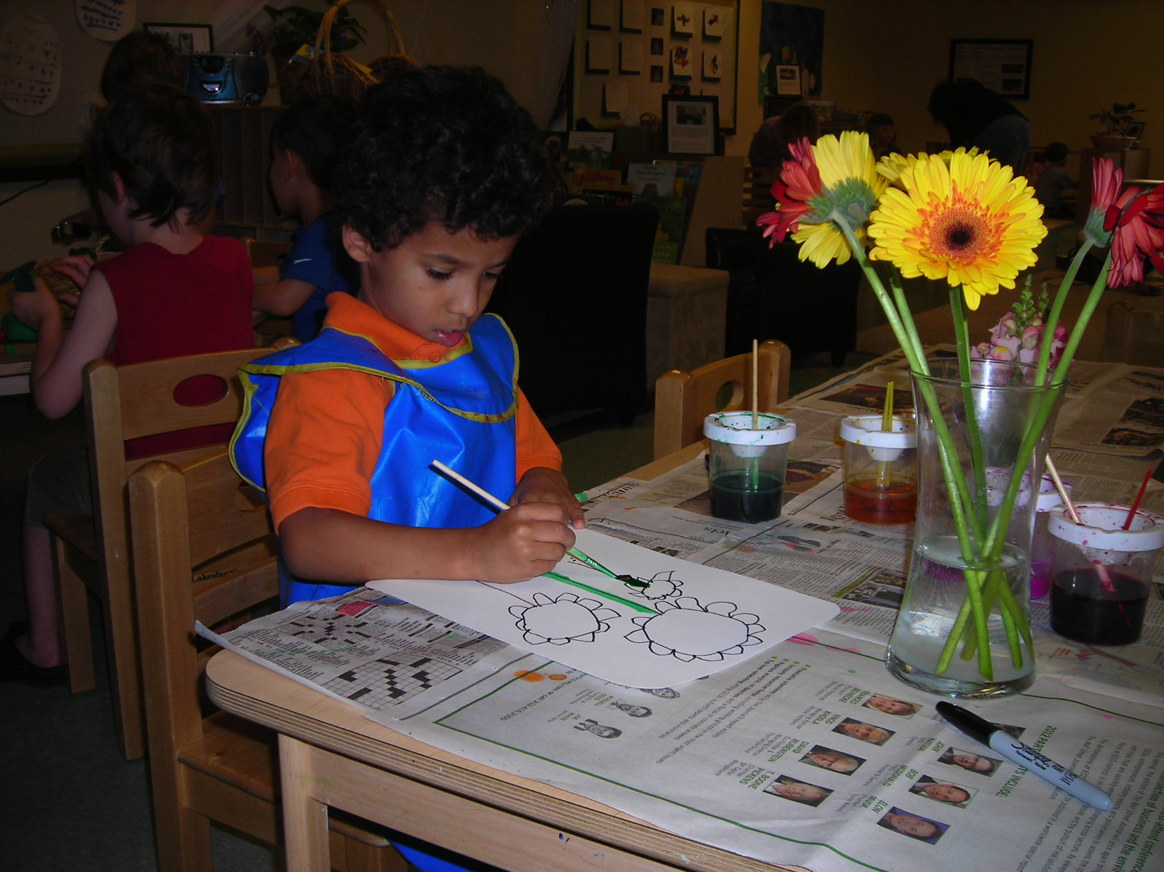

Arts Based Learning
Children express their thoughts and feelings about what they are learning through a variety of arts such as visual arts like coloring and sculpting, music, language, dance, and drama. Children are naturally creative and derive much pleasure from involvement in the arts. They learn new skills and acquire tremendous self-esteem when given the opportunity to create with words, paints, clay, instruments, costumes, puppets, and more.
We celebrate our children's creativity by displaying their work in the classroom and around the church. We believe the artistic process to be even more valuable than the final product. Therefore, some of the children’s own thoughts about their creations accompany the display, picture, or video as part of our documentation process.
Children are able to participate in the arts through their own self-directed play but also through special instructors. Children participate in weekly music classes in which they enjoy singing songs, being introduced to new instruments, and playing instruments along with the music while being introduced to different genre’s and styles of music. Children also participate in drama classes where they get to participate in puppet shows, act out a story on stage, and play imaginative games. Throughout the year special guest instructors lead art projects and share their arts expertise.

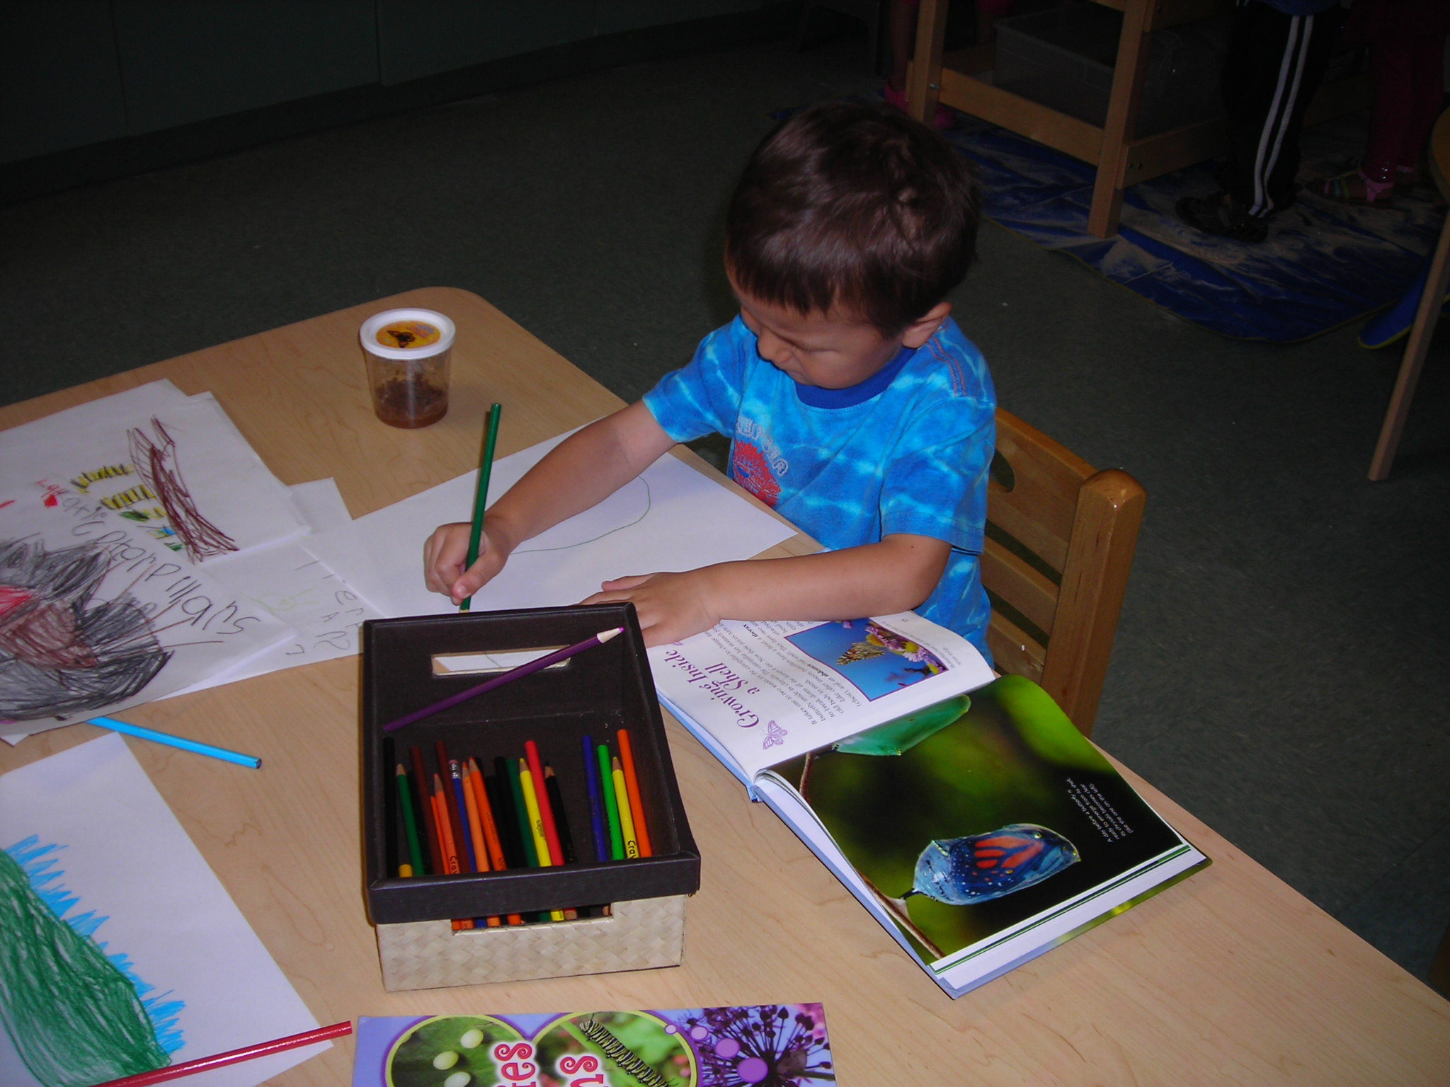

Literacy Position Statement.
Learning to read and write is one of the most critical predictors of a child’s success in school and later in life. The early childhood years, from birth to age eight, are the most important time for literacy development (Neuman, Copple, Bredekamp, 2000). Literacy development begins in the toddler years. Young children need to be engaged in literacy activities that are meaningful and that build on their prior experiences and learning. When an early childhood classroom is literacy rich, it encompasses the following components:
- shared reading activities
- guided writing experiences
- children have immediate access to an expansive classroom library with many types of literature activities that encourage children to “play with language” using rhyme and rhythm to engage them in phonological experiences
- opportunities to use the language in a meaningful way in their daily interactions in the classroom

Literacy goals for children exiting UPC Discovery for kindergarten are consistent with the recommended accomplishments from the National Research Council’s Preventing Reading Difficulties in Young Children. The child leaving UPC Discovery for kindergarten will:
- recognize print in the local environment
- understand that different text forms are used for different functions of print (i.e. a list for groceries is different from the list on the menu)
- understand and follow oral directions
- be sensitive to some sequences of events in stories
- show an interest in books and reading
- identify about 10 alphabet letters, especially those in own name
- write (scribble) messages as part of play activity
- begin to attend to rhyming sound in common words

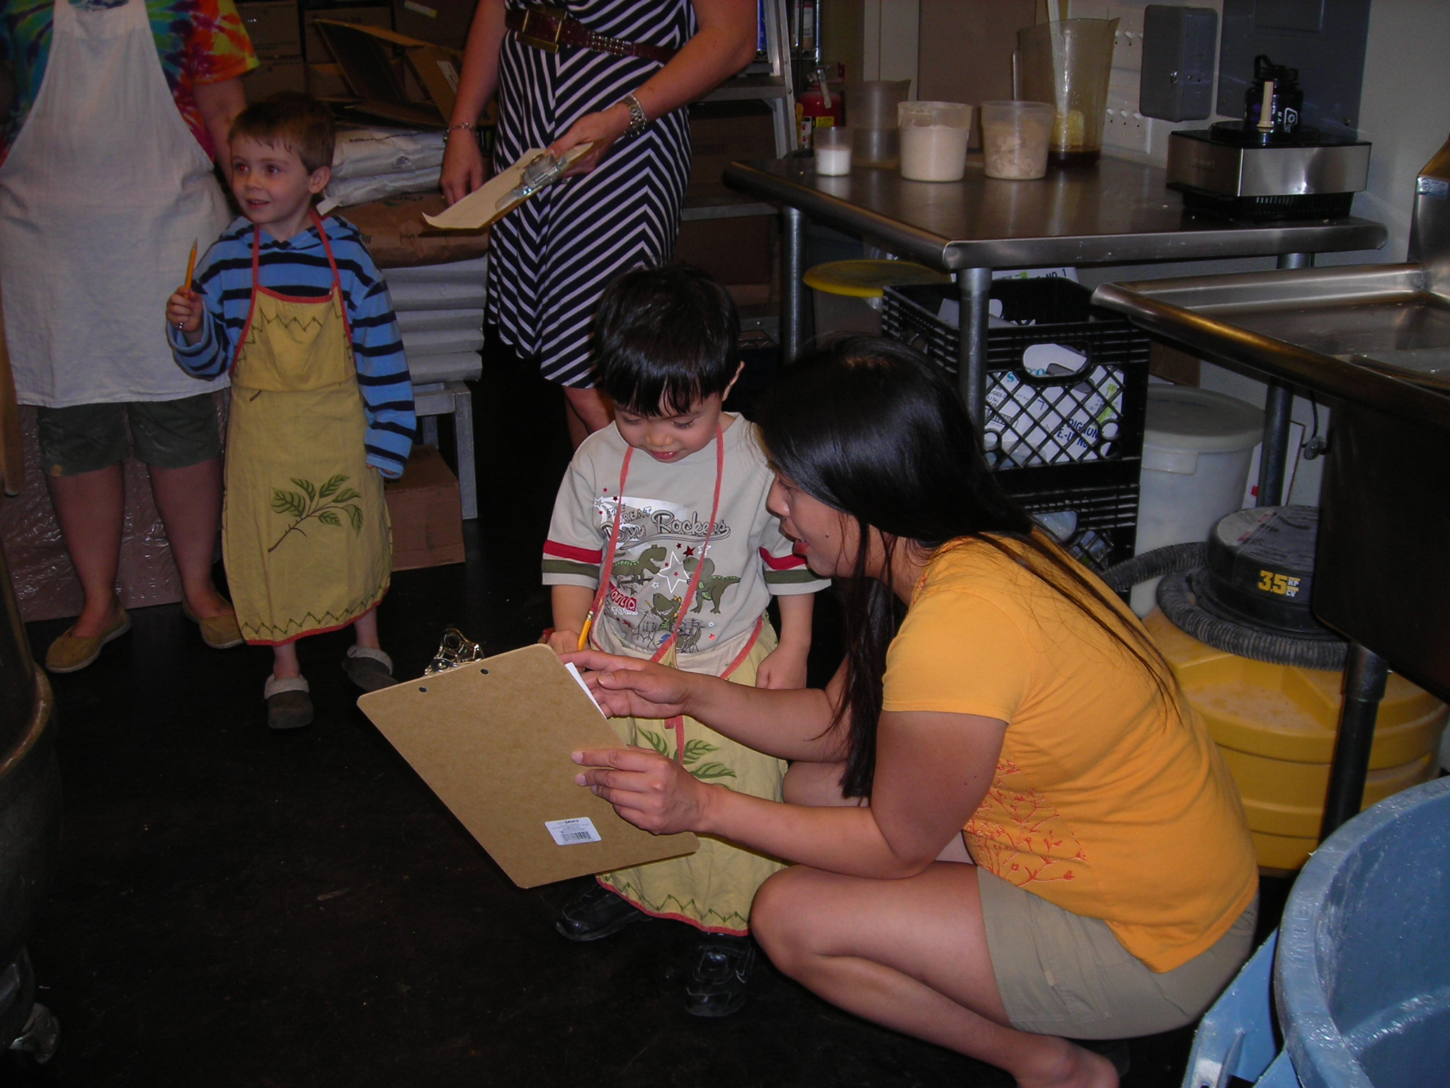

Work Sampling
Our children are evaluated using the work sampling system. This assessment tool evaluates the children in seven developmental domains: Language, Math, Intellectual Disposition, Social Studies, Spiritual Development, Social and Physical Development. Teachers collect children’s work and organize it into a portfolio; they record their growth using developmental checklists, and write a summary report at the end of each collection period. This information is shared with the child’s family two times a year in a conference format. The Work Sampling System has been aligned with Illinois Early Learning and Development Standards that guide our curriculum goals at UPC Discovery.

Toddler Assessment
Children in our toddler program are assessed using a modified version of the Work Sampling System that is more aligned with toddler developmental milestones. Using a developmental checklist and toddler core items, teachers evaluate the children’s learning twice a year and hold parent/teacher conferences to share their information. Conferences are scheduled to coincide with preschool conferences to minimize scheduling conflicts for families with children in both programs.

Quick Reference Sheet

Director: Lora Taylor

UPC Discovery Early Learning Center
United Presbyterian Church
2400 W Northmoor Road
Peoria, IL 61614
Phone: 693-7296

Email: lora.taylor@upcdiscovery.org
Website: www.unitedpc.org



Thank you for participating in the programs at UPC Discovery!



